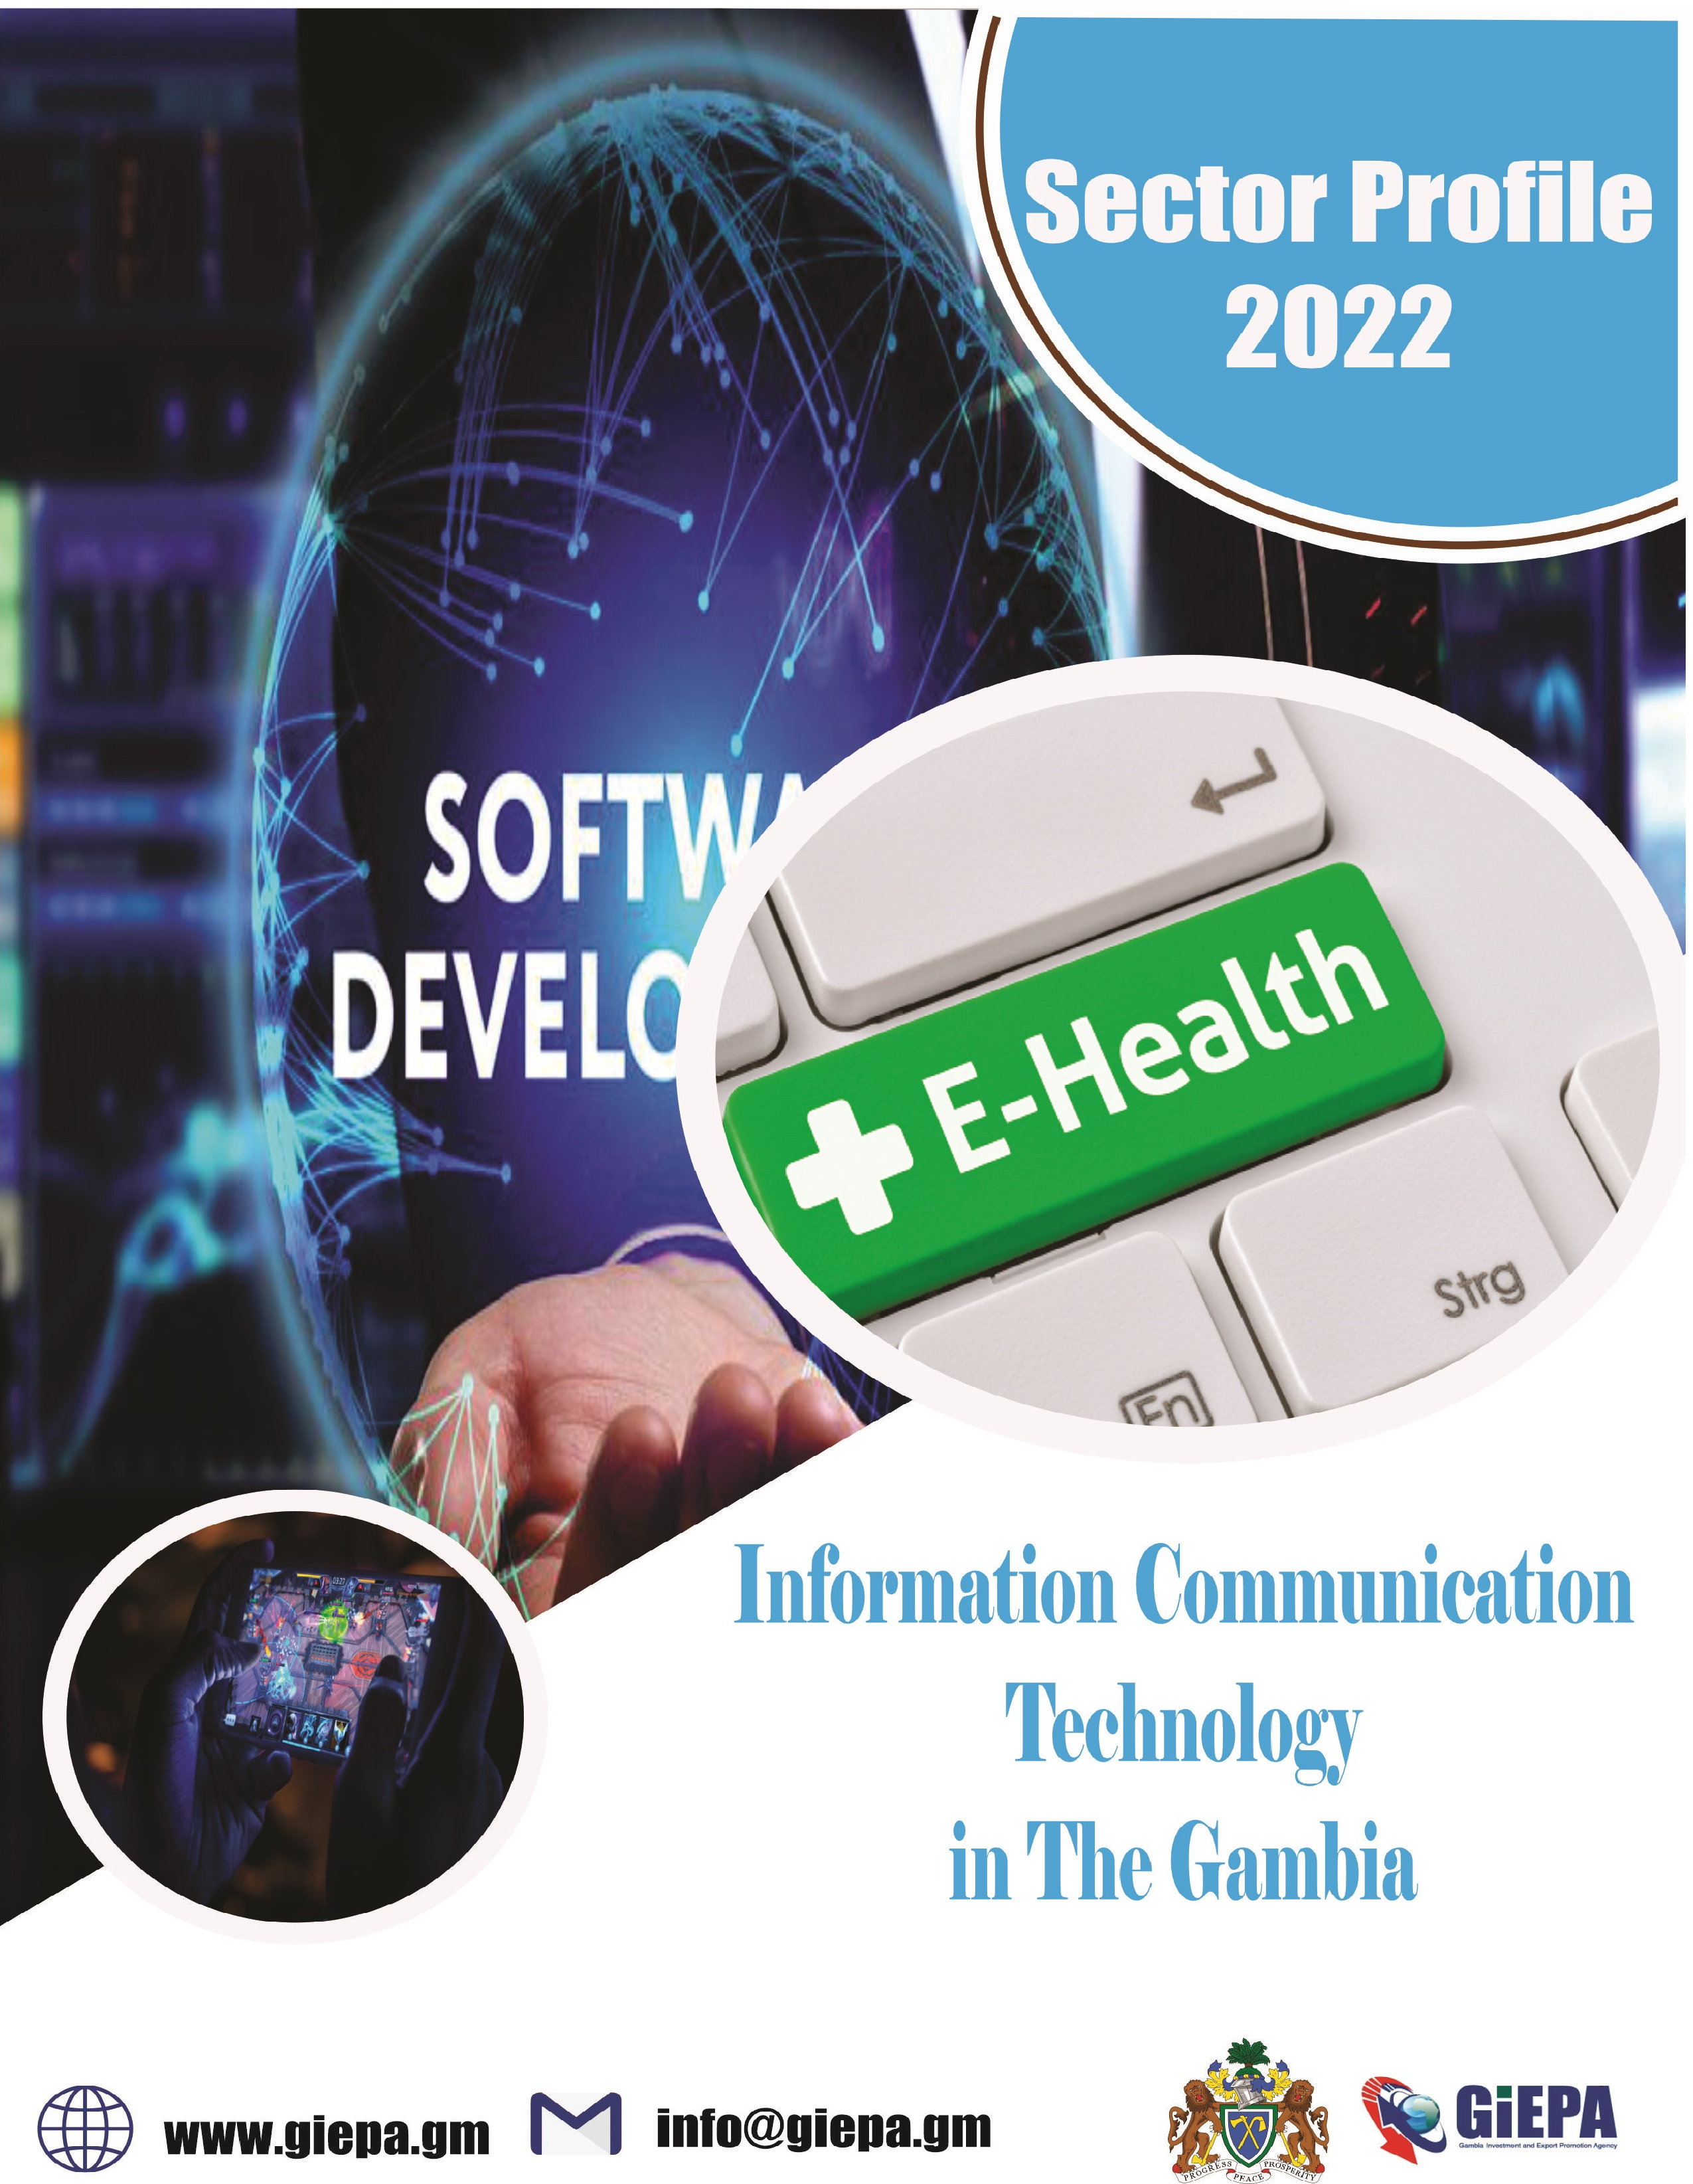

Table of contents
ICT
Why The Gambia…………………………………………………..1
Economic indicators………………………………………………..2
Locations
Infrastructure………………………………………………………..3
E-Commerce………………………………………………………..4
E-Education………………………………………………………...4
E-Health Records………………………………………………….5
E-Insurance………………………………………………………...5
E-Procurement……………………………………………………..6
Mobile Gaming and Software Development…………………….6
SMART Grid Development……………………………………….7
Four good reasons to Choose the Gambia……………………..8
Availability of incentives…………………………………………..9
Operating Costs…………………………………………………...9
Government Policy Position……………………………………..10
A helping hand – every step of the way………………………...10
Reference

Why The Gambia ?

The Gambia has a growing economy and rising purchasing power. As the country becomes more connected via ICT there is a growing opportunity for e-commerce capabilities to serve the increasing business-to-customer trade that is taking place. The Gambia also acts as an excellent entry point to the wider West African region with major economies like Nigeria and Ghana and a total population of around 340 million.

This document outlines:

- The market opportunity for ICT Sector
- The favourable conditions available to investors
- The support investors can expect to receive
- The risk and sustainability factors to be considered
The best Institutions quality in West  Africa | Stable political and regulatory environment | 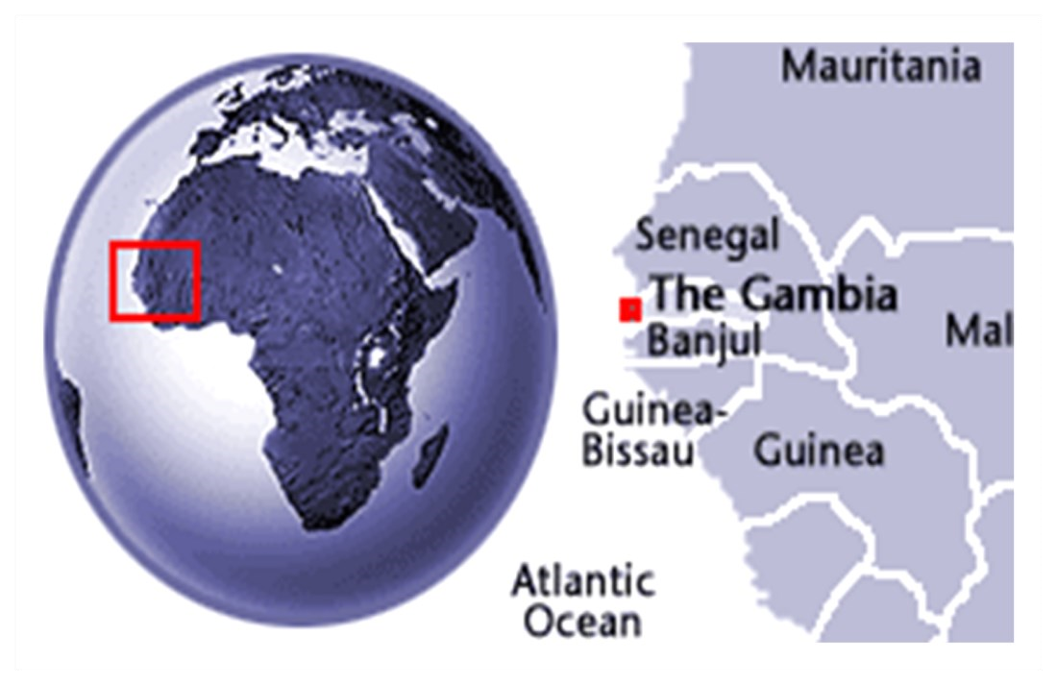
Growing population with increasing purchasing power. | The Gambia is ranked highly for its use of ICT.

Economic Indicators

- GDP: US$2,036mm in 2021.
- GDP growth: 4.3% in 2021.
- Country risk: Lower risk level (yellow) than all neighboring countries
- CPI Inflation (2021): 7.607
- Exports / Imports value (2020) : - Exports: $28.7mm Import: $725.7mn.
- Labor force (2019) : 781,558
- FDI stock and inflows (2020): $519.217mm stock / $46mm inflows.
- Currency exchange rates (2021) – highs (H) and lows (L):
- GMD/USD: 52.61 (H)/51.07(L)
- GMD/GBP:71.1(H)/ 68.24(L).
- GMD/EUR: 61.87 (H)/60.57(L)
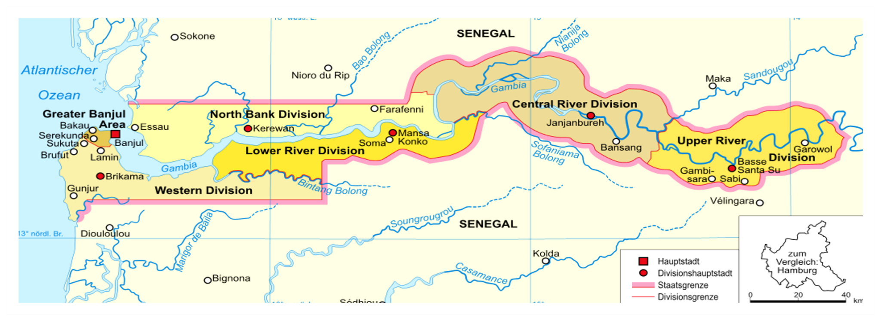
Locations

The population of The Gambia is becoming increasingly urbanised and concentrated in and around the major cities of the Western region. The urban centres of Banjul, Serrekunda, Bakau etc. have excellent ICT connectivity and large populations of students at all levels.
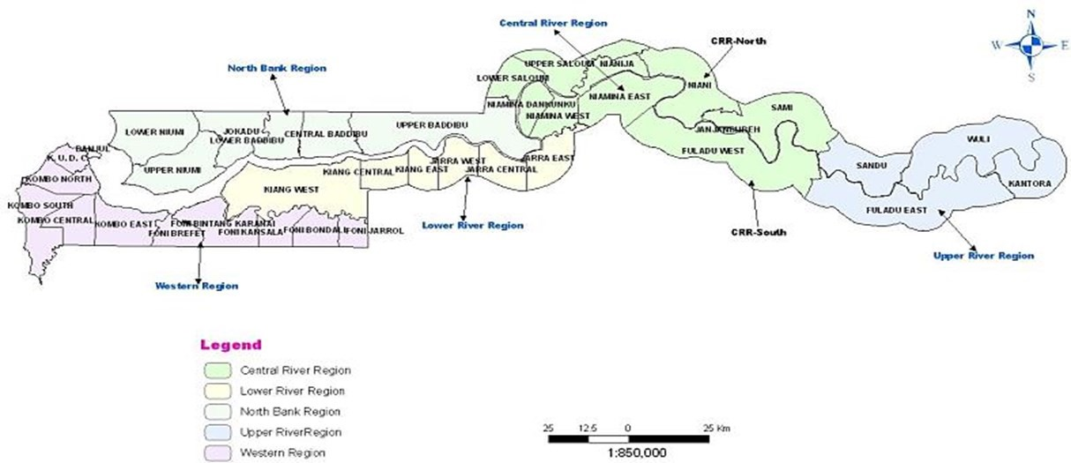
Infrastructure

- The ACE (Africa Coast to Europe) submarine communications cable runs from France to South Africa along the West coast of Africa. It is managed by a consortium of 17 operators, headed by Orange. The 1st phase of the 17,000km fibre optic cable was put into service in December 2012 with the official inauguration ceremony taking place in Banjul.

- Banjul Airport has undergone a US$21 million modernisation and the Government is continuing to upgrade the infrastructure
- The Trans-Gambia bridge
Other new infrastructure / upgrades in development:
- Improved cross-border trunk roads with Senegal
- Ports Expansion Programme underway – Gambia Ports Authority planning to build a second port on the Atlantic coast
- Ongoing infrastructure upgrades at Banjul International Airport

E
-
Commerce In The Gambia

E-Commerce in The Gambia has yet to become an established method of purchasing goods. However, recent and ongoing improvements to ICT connectivity and energy reliability are opening the country up as an excellent location for investment. The economy is predicted to grow steadily in the coming years, leading to a greater market for e-commerce services.

E-Education in The Gambia
The Gambia’s E-Education industry is in its infancy but recent and ongoing improvements to ICT connectivity and energy reliability are opening the country up as an excellent location for foreign investment.
Its young and increasing population provide a large market for ICT in education, both as a tool in classrooms and as a facilitator of distance learning.

E-Health Records in The Gambia
The usage of e-Health in the Gambia is currently limited but recent and ongoing improvements to ICT connectivity and energy reliability are opening the country up as an excellent location for foreign investment in this area. Its growing population and increasing GDP mean that the country is in increasing need of e-Health solution providers to increase both quality and efficiency of the healthcare system within the country. The use of mobile clinics is widespread and the ability to access patient records remotely would be of huge benefit to the health of many Gambians.

E-Insurance In The Gambia

The Gambia’s e-Insurance industry is in its infancy but recent and ongoing improvements to ICT connectivity and energy reliability are opening the country up as an excellent location for foreign investment. Its cost-competitive workforce, growing population and increasing GDP mean that the country is in increasing need of einsurance solution providers.

E-Procurement In The Gambia
E-Procurement in The Gambia has yet to become an established practice among businesses and government. However, recent and ongoing improvements to ICT connectivity and energy reliability are opening the country up as an excellent location for investment. The economy is predicted to grow steadily in the coming years, leading to a greater market for eprocurement services.

Mobile Gaming & Software Development
The Gambian Government has ambi- tions to develop the country into an ICT hub and the development of mobile gaming and software is very much at the forefront of this strategy. Its costcompetitive workforce of native English speakers as well as its extremely high mobile telephone ownership and usage make the country an ideal location to invest in.

Smart Grid Development in The Gambia

As The Gambia continues to develop its services and manufacturing industries, it is having to also develop its energy reliability. Public-Private Partnerships are a preferred method of funding large scale energy projects in The Gambia and as the ICT infrastructure improves there is a large opportunity for a smart grid system to be developed.

Companies investing in The Gambia have a domestic market of 1.75 million people but the country’s well-developed infrastructure ensures that all major markets, including Senegal’s large population of more than 12 million people, are only a short drive away. The Gambia’s trade agreements and advantageous positioning in the heart of West Africa also provides investors with unrivalled access to some of the world’s fastest growing economies.

4 Good Reasons to Choose The Gambia
STRONG DEMAND AND IDEALLY LOCATED:
- There is a growing need for ICT and BPO services globally and cost is the major factor for investors when considering where to establish operations.
- The Gambia offers extremely competitive labour costs.
 | 1 |  |  | - The Gambia’s position on the continent makes it the ideal location from which to enter the wider West African market.  - The Gambia’s location in the GMT time zone makes it the ideal location for a BPO/contact centre.  - The Gambia’s location is excellent for providing insurance services to the European and West African market
2 |  |  | COMPETITIVE INVESTMENT ENVIRONMENT:  - The best Institutions quality in West Africa (WEF 2014)  - West Africa’s most efficient labour market (WEF 2014)  - 5th lowest political risk level in the sub-Saharan Africa (AON)
ENGLISH SPEAKING COUNTRY:

• Foreign investors find it easier to conduct business in Gambia than in other West African countries. English is the country’s official language and the most commonly spoken language in the business arena.
3
ATTRACTIVE INCENTIVES, COMPETITIVE COSTS:
- Competitive costs
- Strong political support for telecommunications industry
- Comprehensive guidance and support from GIEPA
4
Availability of Incentives

ICT services is one of the priority sectors for investment and a host of incentives are available to investors in e-Commerce. These incentives include:
- Tax Holiday: tax breaks on corporate and turnover tax, withholding tax on dividends and for a period of 5-8 years, depending on the project’s location
- Import Tax Incentives: Exemption from payment of import tax on direct inputs for the project (e.g. IT hardware).
- Export Incentives: Exemptions / reductions on corporate and turnover tax, exemption from Excise Duty and VAT on goods produced or imported within the Export Processing Zone (EPZ) for processing and export – depending on proportion of goods exported.
Operating Costs
The Gambia has by far the most efficient labour market in West Africa7 and offers competitive costs in key areas both regionally and globally.

Competitive rates for key utilities such as energy and water are offered to operators in the ICT sector.

Government Policy Position
⇒ The Gambian Government recognises the importance of private sector participation in the economy, both as an engine of growth and as a source of knowledge transfer.
⇒ The ICT sector has been targeted as an industry with the potential for growth and the government are taking proactive steps toward stimulating investor interest and growth in the sector. This includes increased liberalisation of ICT services and the development of modern ICT legislation.

⇒ The Gambia Investment and Export Promotion Agency (GIEPA) has identified ICT as one of the core activities to be pursued.

A Helping Hand—Every Step of The Way
The Gambia Investment and Export Promotion Agency (GIEPA) is the Government Agency mandated to support companies with their investment, business and export development as well as support to MSMEs.

From the initial provision of information right through to supporting the establishment, growth and development of an investment project, GIEP is your supporting partner for doing business in The Gambia – every step of the way.

Here are just a few of the ways in which GIEPA can support your business:

Provide all business
-
related information to
current and potential
investors

Serve as the link

between investors
and authorities

Help to identity
joint

venture partners

Help to identity
joint

venture partners

Provide advisory

services and
training to

exporters

Support

companies plan-
ning to expand/
diversify

Provide ongoing
assistance to
companies once
they
’
ve started
operations

Administrator and

advise

on incentives

Reference
- World Economic Forum

- Aon political risk map.
- World Economic Forum Global Information Technology Report
- Gambia Bureau of Statistics (GBOS)
- 5 International Telecommunication Union
- World Economic Forum Global Competitiveness Report
- Program for Accelerated Growth and Employment
- Interview with Lasting Solutions 9 www.pura.gm
- 4 UN Comtrade.
- International Telecommunication Union
- World Economic Forum Global Information Technology Report
12.10 PURA www.pura.gm
13.UNCTAD stat.

