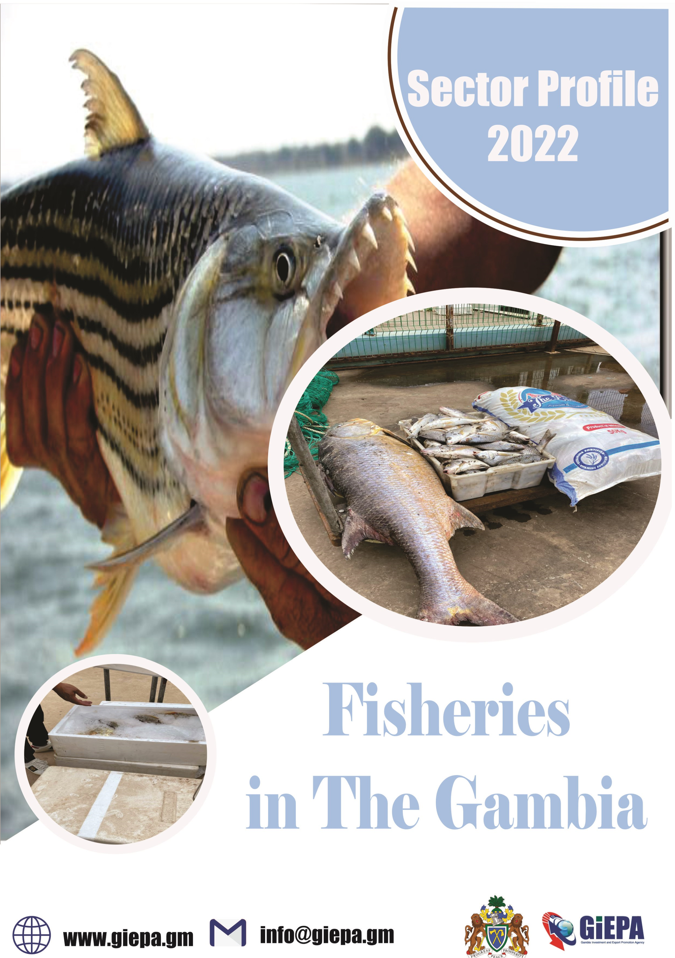

Agriculture In The Gambia

Table of Content
Why The Gambia…………………………………………………………………… 1
Economic Indicators………………………………………………………………. 2
Infrastructure………………………………………………………………………… 3 The Gambia’s Fisheries Community….…………………………………… 4
Cockle and Oyster Farming in The Gambia….………………………… 5
Cold Storage Facilities in The Gambia……...…………………………….7
Fishing Industry and By-products in the Gambia………………….. 9
Fish Farming in The Gambia………………………………………………….11
Fishery Hualage in The Gambia…………………………………………… 13
Fishing Boats in The Gambia…………..……………………..…………….15
Fishing Equipment in The Gambia………………………………………..16
Ice Plant in The Gambia……………………………………………………….17
Industrial Fishing in The Gambia………………………………………….18
Seafood in The Gambia……………………………………………………….19
Shrimp Industry in The Gambia…………………………………………..21
Smoke Houses in The Gambia……………………………………………..22
Export Agreement & Incentive………………..………………………….23
Government Policies & Operational Cost…………………………...24
Reasons to choose The Gambia……………………..…………………..25-27
Project Risk and Sustainability Factor………………………………….27
A helping hand every step of the way………………………………….28
Reference……………………………………………………………………………29

Why The Gambia?
Situated on the Atlantic coast and with a navigable river that flows more than 1,100km inland. The Gambia is the ideal entry and exit point for West Africa and the Economic Community of West African States (ECOWAS).

This document outlines:
The market opportunity for investment in fishery sector.
The favorable conditions available to investors.
The support investors can expect to receive.
The project risk and sustainability factors to be considered.
The most competitive country in West Africa |  | Average Crop Production one of the highest in West Africa
Home to the only West African river easily accessible to ocean-  going shipping |  |  | One of the most efficient labour market in West Africa
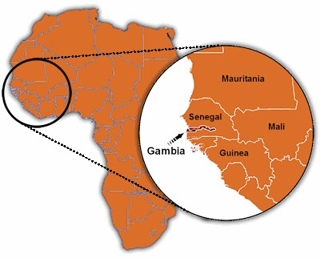
1

Economic Indicator
- GDP: US$2,036mm in 2021.
- GDP growth: 4.3% in 2021.
- Country risk: Lower risk level (yellow) than all neighboring countries and in the same category as sierra leon, Ghana, Togo and Benin.
- CPI Inflation (2021): 7.607
- Exports / Imports value (2020) : - Exports: $28.7mm Import: $725.7mn.
- Labor force (2019) : 781,558
- FDI stock and inflows (2020): $519.217mm stock / $46mm inflows.
- Currency exchange rates (2021) – highs (H) and lows (L):
- GMD/USD: 52.61 (H)/51.07(L)
- GMD/GBP:71.1(H)/ 68.24(L).
- GMD/EUR: 61.87 (H)/60.57(L)
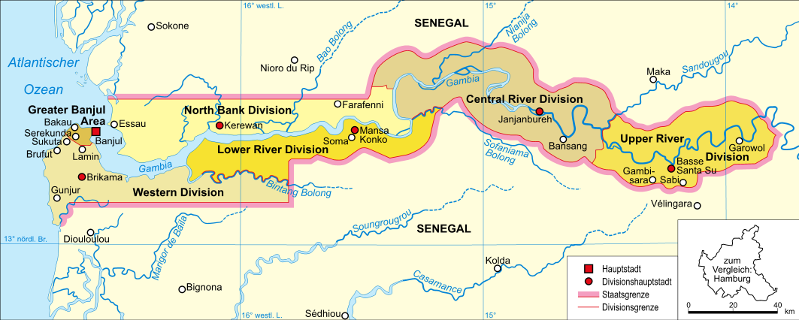
2
Infrastructure

- Banjul port has a handling capacity of
⇒ 48 metric tonnes of bulk cargo per hour.
⇒ 17 container moves (discharging and loading) per hour.
- Other new infrastructure / upgrades in development.
- The Trans-Gambia bridge.
- Improved cross-border trunk roads with Senegal.
- Ports Expansion Programme underway.
- Gambia Ports Authority planning to build a second port on the Atlantic coast.
- Ongoing infrastructure upgrades at Banjul International Airport.
- Gambia Port Authority is assessing the potential establishment of an inland port to facilitate shipping to inland location across the region.

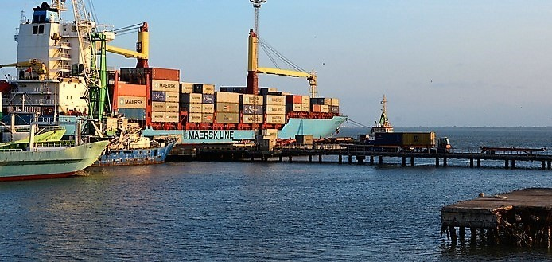
3

The Gambia’s Fisheries Community
- The Gambia is already home to a developed community of stakeholders in the fisheries industry (including businesses, industry associations and representative groups) – a few examples of these organisations are displayed below.
- The presence of these groups demonstrates The Gambia’s attractiveness and potential as a prime location in West Africa for industrial fishing, boat for rental, fishing rental equipment, investment in modern facilities, aquaculture, including ice plants and cold storages, industrial fishing and shrimp and crayfish farming.
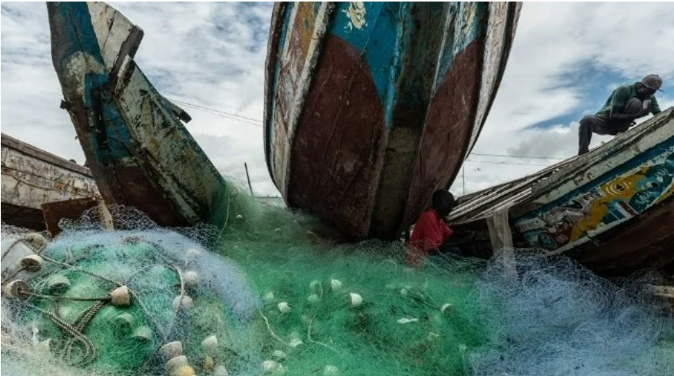
Sources : The Maritime Executive Accessed 03/08/2022
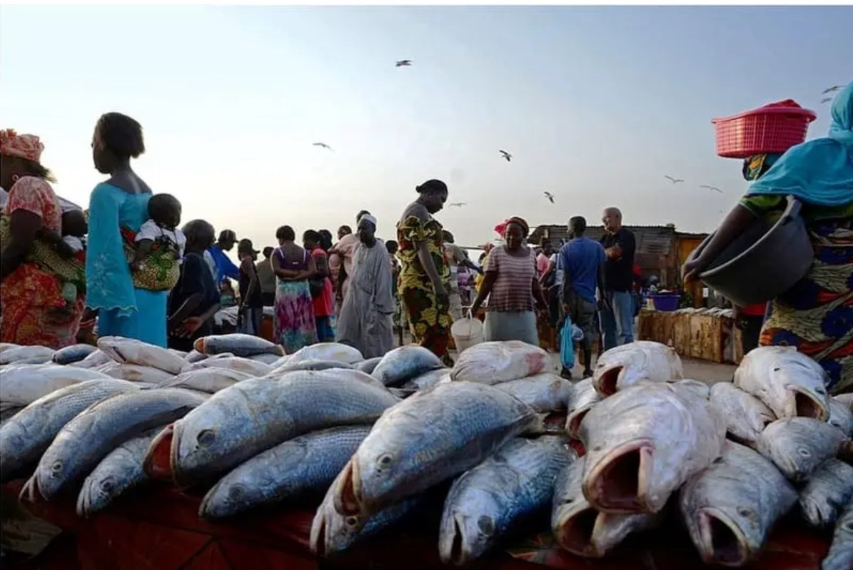
Sources : The Voice Accessed 03/08/2022
4

COCKLE AND OYSTER FARMING IN THE GAMBIA

- The Gambia’s 100 miles of brackish inland water system – the rivers, estuaries, and tributaries – provide extensive mangrove (4% of the Gambia’s surface) and favourable conditions for shelters and nurseries of oysters.
- The Gambia’s aquaculture industry is currently dominated by artisanal activity and commercial cockle and oyster farming is still a largely untapped area of opportunity.
- Additionally, with further population growth, increasing urbanisation and high cost of other animal proteins, domestic demand for seafood is set to rise.

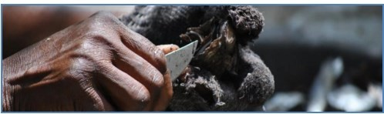
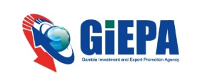 5

The Gambia’s Cockle and Oyster Community
EXAMPLE OF ORGANISATION
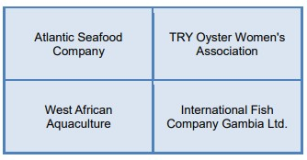

Location
- There are plenty of opportunities for cockle and oyster farming along the mangrove -rich tributaries of the River Gambia, with areas such as Tanbi National Park, Tumani Tenda Eco-Reserve and Denton Bridge seeing significant levels of oyster farming.
- A lack of industrial activity on the River Gambia has ensured an ideal environment for cockle and Oyster farming. Recent surveys’ results show that both total coliform and fecal coliform counts are among the lowest counts in many tropical oysters and suggest that a shellfish sanitation program could allow for safe harvest of live oysters.
- Banjul Port is conveniently located at the mouth of the River Gambia, making it easily accessible to trawlers and other boats navigating the coast as well as the river.
6

Cold Storage Facilities in The Gambia
- To maintain sanitary condition for seafood exports to EU and the US, fishermen, collectors and processing companies are in high need of ice and cold storage facilities, representing great opportunities for foreign investors.
- The Gambia has some 134 landing sites for small-scale fisheries, of which only a few have basic facilities, such as a landing quay, fuel, ice and water supply and space to preserve the fish. Four landing sites will receive infrastructure funded by the AfDB .
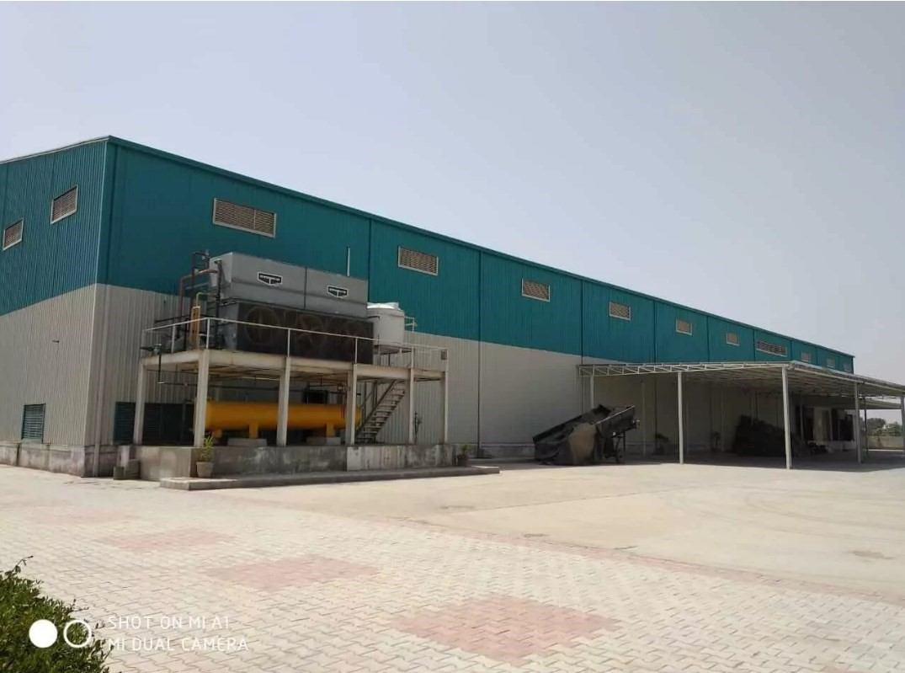
Source : Yogesh Dahiya Accessed 02/08/2022
7

The Gambia’s Cold Storage Community Community
EXAMPLE OF ORGANISATION
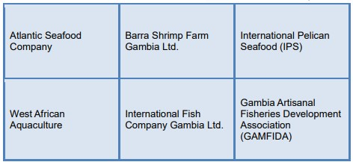

Location
- With 80km of coastline and a continental shelf area of 4,000km2 , The Gambia offers the ideal environment for industrial fishing and the development of cold-chain infrastructures. With extremely rich marine resources, the Gambian fishing industry is expanding to meet the domestic, sub region and foreign demand for fish.
- The domestic roads network to the sub-region and the efficient freight traffic of Banjul’s port have contributed to rank Gambia as a top location for trade activities in the sub-Saharan region.
- Banjul Port is conveniently located at the mouth of the River Gambia. Easily accessible to trawlers and other boats navigating the coast as well as the river and its tributaries, it has become a fishing hub and an ideal location for mid and large scale seafood storage facilities.
8

Fishing Industry and By-Products in The Gambia
- With 80km of coastline and a continental shelf area of 4,000km2 , The
Gambia is home of a rising industrial fishing industry and aquaculture

farming. The increasing number of catches and export volumes of fresh and processed fish have created large opportunities in the production of fish low and high added value by-products from fish waste, including fish oil, fish feed, fish leather, fish heads and bones.
- The Gambia’s fish processing industry is a growing sector currently dominated by 11 companies that processes fishes in low value added products.
- The accelerating development of the industry as left untapped opportunities in the production of value added by-products from fish waste. Only about 36-43% of the total body weight of a pelagic fish ends up being consumed by humans, leaving around 60% as a high volume available for the production of valued added by-products.

Fish Species in The Gambia Waters
DERMASAL SPECIES:
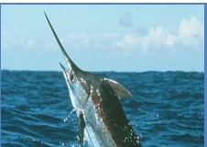
- Sole
- Grunts
- Sea-breams
- Carangids
- Cephalopods
- Bonga
- Sardinella
- Red Mullet
- Shads
- Catfish
- Jackss
- Snappers

The Gambia’s Fishing Industry and By-Products Community
EXAMPLES OF ORGANISATIONS:
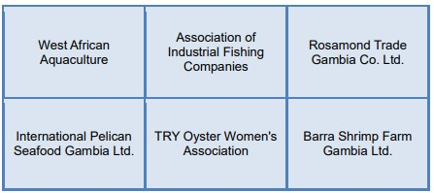

Locations
- The Gambia’s 80km coastline provides an ideal location for the fish industry and the export and re-export of fish by-products to western and the sub-region markets.
- The River Gambia has saltwater as far as 150km upstream and 4,000 sq km of continental shelf, which offers great locations for aquaculture farming. Banjul Port is conveniently located at the mouth of the River Gambia, making it easily accessible to trawlers and other fishing boats navigating the coast as well as the mouth of the river.
- The navigable river Gambia and tributaries flow more than 1,100km inland, by-products can therefore easily be packaged, labelled and transported at various points throughout the country. Existing packaging operations are found in Serrekunda and the coastal region, although these are currently very limited.

10

Fish Farming in The Gambia
- The Gambia’s inland waters – the river, estuaries, and tributaries – provide extensive mangroves and favourable conditions for fish farming.
- The Gambia’s aquaculture industry is currently dominated by artisanal activity and commercial fish farming is still a largely untapped area of opportunity.
- UNCTAD describes the Gambian aquaculture sector as embryonic but deemed to have huge growth potential.
- Additionally, with further population growth, increasing urbanisation and high cost of other animal proteins, domestic demand for fish is set to rise.
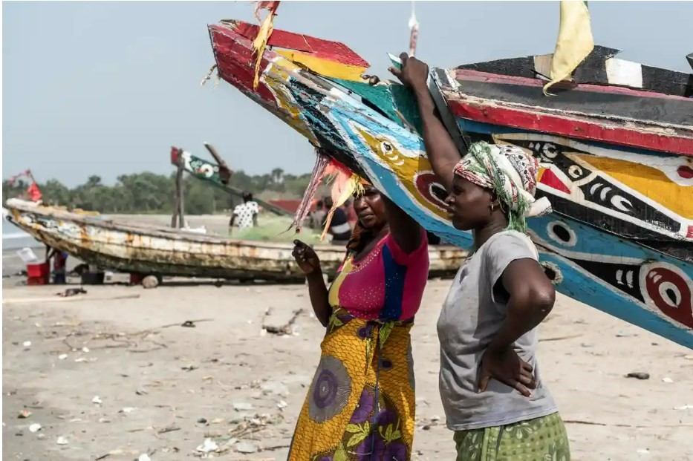
Source : Theguardian.com Accessed 02/08/2022

11

The Gambia’s Fish Farming Community
EXAMPLES OF ORGANISATIONS
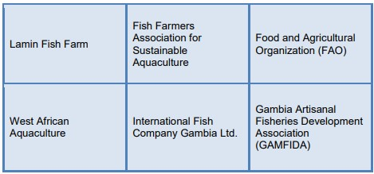

Locations
- There are plenty of opportunities for fish farming along the mangrove-rich tributaries of the River Gambia as well as along the Atlantic coast. Sanyang and Lamin (both in the Western Region) are just two of The Gambia’s centers for fish farming and other forms of aquaculture, as are numerous locations in the Central River Region.
- A lack of industrial activity on the River Gambia has ensured an ideal environment for fish farming. There’s no pollution from up-river, reducing the need for antibiotics in fish farming.
- Banjul Port is conveniently located at the mouth of the River Gambia, making it easily accessible to trawlers and other boats navigating the coast as well as the river and its tributaries.

12

Fishery Haulage in the Gambia
- Fisheries transportation services is undeveloped in the Gambia despite huge opportunities implied by commercially viable stocks of demersals, crustaceans, cephalopods, molluscs, and pelagic (sardinella, red mullet, horse mackerel, cranx, shads, cat fish, grunts, jacks, and snappers).
- The Gambia’s fishing industry is currently dominated by artisanal activity and industrial fishing is still a largely untapped area of opportunity.
- Within the artisanal fisheries distribution chain, dealers sometimes collectively hire a commercial vehicle to transport the fish to the urban markets, or use local taxis.
- Industrial fish processors export almost exclusively their products to EU, USA and Asian markets but also in the sub-region where huge untapped market opportunities exist.
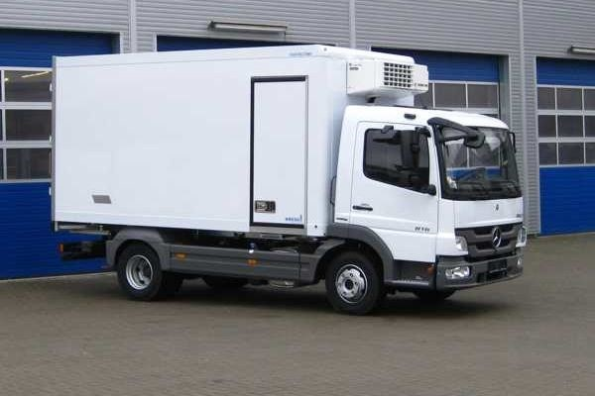
Source :https://www.kress.eu/en/products/trade-solutions/fish-transportation.html : Accessed 03/08/2022

13

The Gambia’s Fishery Hualage Community

EXAMPLES OF ORGANISATIONS:
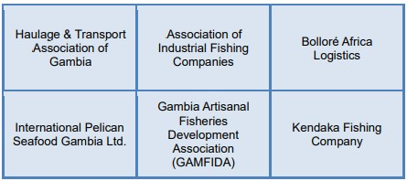

Location
⇒ | The domestic growing fisheries sector is supporting the development of large opportunities for transport and logistics companies.
⇒ | The Gambia’s 80km coastline and its 4,000 sq km continental shelf provide an ideal location for the fish industry and the export and re-export of seafood products to western and the sub-region markets.
⇒ | Banjul Port is conveniently located at the mouth of the River Gambia, making it easily accessible to trawlers and other fishing boats navigating the coast as well as the mouth of the river. The navigable river Gambia and tributaries flow more than 1,100km inland.
⇒ | There are plenty of opportunities for industrial fishing along and off The
Gambia’s 80km coastline and within its 4,000 sq km continental shelf. The
River Gambia has saltwater as far as 150km upstream

14

Fishing Boats In The Gambia
- With 80km of coastline and a continental shelf area of 4,000km2 , The
Gambia offers the ideal environment for industrial and artisanal fishing.
- Within this continental shelf area, there are commercially viable stocks of demersals, crustaceans, cephalopods, molluscs, and pelagic (sardinella, red mullet, horse mackerel, cranx, shads, cat fish, grunts, jacks, and snappers).
- There are about 20 locally registered fishing companies. Although the number keeps increasing, only four fishing companies have managed to acquire fishing trawlers; the rest of the companies depend solely on supplies from artisanal fishermen to feed the fish factories (there is always undersupply and factories operate below capacity).
- The dependence of most seafood processors and exporters on the growing unreliability artisanal fish supply has created investment opportunities for the lease of trawlers and mid-size fishing boats to fishing companies keen to secure a stable supply of fish.
- With further population growth, increasing urbanisation and high cost of other animal proteins the already high demand for fish is set to rise
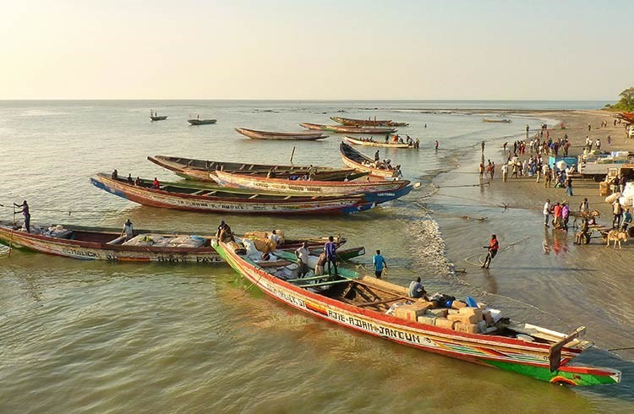
Source : World nomad : Accessed 03/08/2022

15

Fishing Equipment in The Gambia
- With 80km of coastline and a continental shelf area of 4,000km2 , The Gambia offers the ideal environment for industrial, artisanal fishing. Within this continental shelf area, there are commercially viable stocks of demersals, crustaceans, cephalopods, molluscs, and pelagic (sardinella, red mullet, horse mackerel, cranx, shads, cat fish, grunts, jacks, and snappers).
- The vibrant and growing artisanal sector is put pressure on the supply of fishing equipment, including outboard motor, fishing deck equipment, fishing chain, twine, nets & accessories - especially encircling net. There is also a growing market for the rental of sonars for domestic and foreign (mainly Senegalese) industrial trawlers for the capture of pelagic species. With further population growth, increasing urbanisation and high cost of other animal proteins the already high demand for fish is set to rise.

Location
There are plenty of opportunities for industrial fishing along and off The Gambia’s 80km coastline and within its 4,000 sq km continental shelf. The River Gambia has saltwater as far as 150km upstream.
Banjul Port is conveniently located at the mouth of the River Gambia, making it easily accessible to trawlers and other fishing boats navigating the coast as well as the mouth of the river.
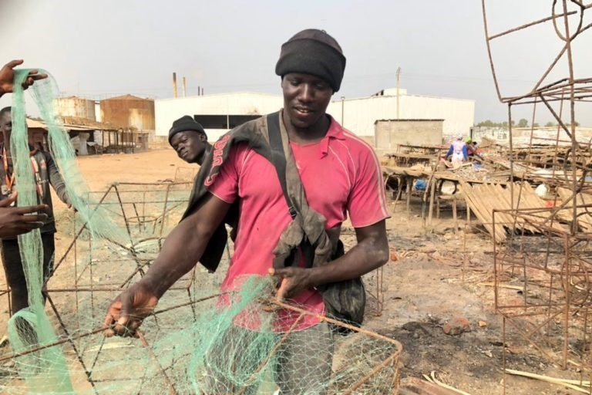
Source : Mongabay Accessed 03/08/2022

16

Ice Plant in The Gambia
To maintain sanitary conditions for seafood exports to EU and the US, fishermen, collectors and processing companies are in need of ice and cooler storage facilities, representing great opportunities for foreign investors. The Gambia has some 134 landing sites for small-scale fisheries, of which only a few have basic facilities, such as a landing quay, fuel, ice and water supply and space to preserve the fish. Four more landing places will receive infrastructure funded by the AfDB. 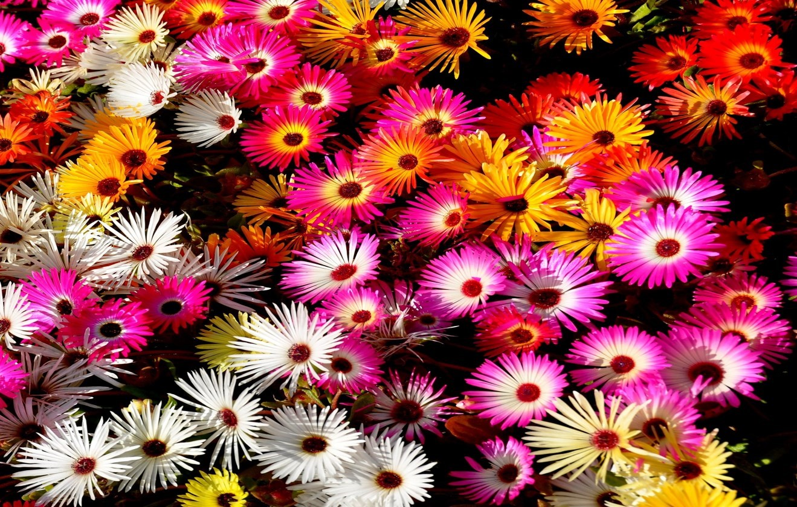
Source : Desertcart : Accessed 03/08/2022

Location
⇒ | With 80km of coastline and a continental shelf area of 4,000km2 , The Gambia offers the ideal environment for industrial fishing and the development of related-facilities, including ice plants. Extraordinarily rich in marine resources, the Gambia’s fishing industry is expanding to meet the domestic, sub region and foreign demand for fish. Domestic roads’ network to the sub-region and the smooth freight traffic of Banjul’s port have contributed to rank Gambia as a top location for trade activities in the subSaharan region.
⇒ | Banjul Port is conveniently located at the mouth of the River Gambia. Easi-
ly accessible to trawlers and other boats navigating the coast as well as the river and its tributaries, it has become a fishing hub and an ideal location for mid to large scale ice plants.

17

Industrial Fishing in The Gambia
◻ With 80km of coastline and a continental shelf area of 4,000km2 , The Gambia offers the ideal environment for industrial fishing. Within this continental shelf area, there are commercially viable stocks of demersals, crustaceans, cephalopods, molluscs, and pelagic (sardinella, red mullet, horse mackerel, cranx, shads, cat fish, grunts, jacks, and snappers).
• The Gambia’s fishing industry is currently dominated by artisanal activity and industrial fishing is still a largely untapped area of opportunity. With further population growth, increasing urbanisation and high cost of other animal proteins the already high demand for fish is set to rise.

Location
There are plenty of opportunities for industrial fishing along and off The Gambia’s 80km coastline and within its 4,000 sq km continental shelf. The River Gambia has saltwater as far as 150km upstream. Banjul Port is conveniently located at the mouth of the River Gambia, making it easily accessible to trawlers and other fishing boats navigating the coast as well as the mouth of the river.
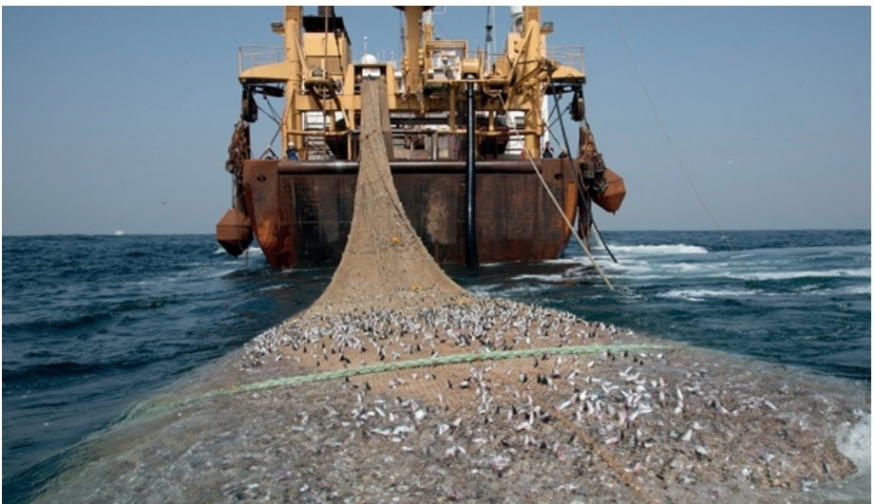
Source : The Chronicle Gambia : Accessed 03/08/2022

18

Seafood in The Gambia
The Gambia produces a significant and diverse set of seafood products for domestic and international consumption, yet the country’s export potential is untapped. A lack of packaging and labelling facilities is partly responsible for hindering this potential. The Gambia is also heavily reliant on imports of seafood products. Here, there is a limited number of suppliers and facilities to repackage bulk imports and redistribute within The Gambia and wider ECOWAS markets. Imported packaging can consequently represent 50% of the price of the end-product for sale.

What can be packaged and labelled
There is an unfulfilled need for a vast range of seafood products to be packaged and labelled in The Gambia – whether domestic products for local consumption and exports, or bulk imports for repackaging and selling in The Gambia and other ECOWAS markets. Here are a selection of products:
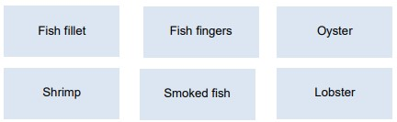

Location
Boats with a draught of up to 6 meters can go as far as 300km up the River Gambia, while the north- and south-bank roads along the river ensure easy access throughout the country. Goods can therefore easily be packaged, labelled and transported at various points throughout the country. Existing packaging operations are found in Serrekunda and the coastal region, although these are currently very limited.
Banjul Port is conveniently located at the mouth of the River Gambia, making it easily accessible to trawlers and other boats navigating the coast as well as the river and its tributaries.

19

The Gambia’s Seafood-Processing and packaging Community
The Gambia is home to a developed community of community of stakeholders in the seafood industry (including businesses, industry associations and representative groups) that require packaging and labelling supplies.
There is currently a gap – and therefore potential market opportunity – in the supply of domestic packaging services, including cardboard, plastic and glass. The presence of organisations such as these demonstrates The Gambia’s attractiveness and potential for investment in the manufacture and supply of packaging and labelling. A few examples of organisations that require or could support domestic packaging operations are provided below:
EXAMPLES OF ORGANISATIONS:
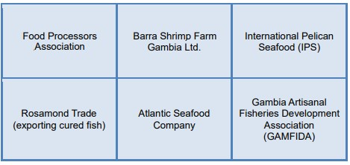
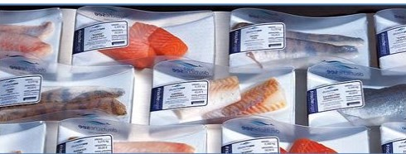

20

Shrimp Industry in The Gambia
The Gambia’s inland waters – the river, estuaries, and tributaries – provide extensive mangrove and favourable conditions for shrimp and crayfish farming. The Gambia’s aquaculture industry is currently dominated by artisanal activity and commercial shrimp and crayfish farming is still a largely untapped area of opportunity. Additionally, with further population growth, increasing urbanisation and high cost of other animal proteins, domestic demand for seafood is set to rise.

Location
⇒ | There are plenty of opportunities for shrimp and crayfish farming along the mangrove-rich tributaries of the River Gambia as well as along the Atlantic coast Sanyang (Western Region) and Kerewan (North Bank Region) are just two of The Gambia’s aquaculture centres.
⇒ | A lack of industrial activity on the River Gambia has ensured an ideal environment for shrimp farming. There’s no pollution from up-river, meaning shrimps can be farmed without antibiotics.
⇒ | Banjul Port is conveniently located at the mouth of the River Gambia, mak-
ing it easily accessible to trawlers and other boats navigating the coast as well as the river and its tributaries.
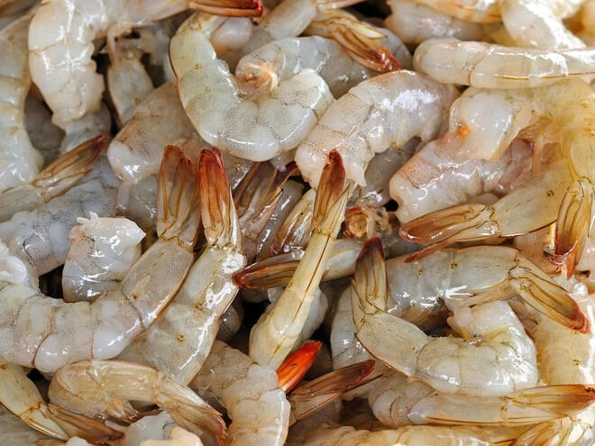
Source : WWF : Accessed 03/08/2022

21

Smoke Houses in The Gambia
- The Gambia has some 134 landing sites for small-scale fisheries, all in need of upgraded smoke houses. Furthermore, there is significant demand of smoke house facilities from some processing plants.
- The bonga, catfish, round and flat sardinella - and other small pelagics - are the main species landed by the artisanal fishermen. These species are mainly consumed locally in fresh or traditionally processed (smoked or dried) product form, or exported regionally. An estimated 30% of landed fish is traditionally processed (dried and/or smoked) and marketed within the country (especially in the inland markets); part of this is then exported to neighbouring West African countries (Senegal, Ghana, Guinea, Nigeria etc) .
- There is a potentially important niche export market for smoked catfish to The Gambian Diaspora in Europe (mainly UK and Netherlands) and the USA . However, the processing techniques and facilities leave much to be desired, hence creating opportunities for foreign investors. Only one factory (Rosamond Trade) was certified to export cured (smoked) fish products to the EU. The remaining had not yet met the EU regulations on fishprocessing establishments.

Location
⇒ | There are plenty of opportunities for shrimp and crayfish farming along the mangrove-rich tributaries of the River Gambia as well as along the Atlantic coast Sanyang (Western Region) and Kerewan (North Bank Region) are just two of The Gambia’s aquaculture centers.
⇒ | A lack of industrial activity on the River Gambia has ensured an ideal environment for shrimp farming. There’s no pollution from up-river, meaning shrimps can be farmed without antibiotics.
⇒ | Banjul Port is conveniently located at the mouth of the River Gambia, mak-
ing it easily accessible to trawlers and other boats navigating the coast as well as the river and its tributaries.

22

Export Agreement
Nearly all Gambian products can be exported at preferential duty rates and quota free to:
- ECOWAS markets under the ECOWAS Trade Liberalization Scheme (ETLS)
- EU market under the Everything But Arms (EBA) Initiative offered by the European Union
- US market under the African Growth and Opportunity Act (AGOA)
- India, Brazil and South Korea under preferential duty rates for products from Least-Developed countries

Incentives
A host of incentives are available to investors in the fishery sector, provided certain criteria relating to investment value and job creation are met. These incentives include:
- Tax Holiday: tax breaks on corporate and turnover tax, withholding tax on dividends and for a period of 5-8 years, depending on the project’s location.
- Import Tax Incentives: Exemption from payment of import tax on direct inputs for the project (e g machinery).
- Export Incentives: Exemptions/reductions on corporate and turnover tax, exemption from Excise Duty and VAT goods produced or imported within the export on fishery export.

23

Government Policies

- The Gambian Government recognizes the importance of private sector participation in the economy, both as an engine of growth and as a source of knowledge transfer.
- The main policy objectives are to: I. Attract investment in the sector.
II. Improve handling and processing of fish and fishery products to conform to international standards.
- The Gambia National Agricultural Investment Programme (GNAIP) 2011-2015 is the national strategic framework for accelerated growth, poverty reduction as well as food, nutrition and income security.
- The Gambia has established the Gambia Food Safety And Quality Agency (GFSQA).
- The government’s fisheries policy is guided by the Fisheries Regulation (2008), the focus of which is the management of the fish resources at the level of the artisanal, industrial and aquaculture sub-sectors
- The Government also plans to Increase the number accredited laboratories— supported by EU—Funded West African Quality Programme.

Operational Cost
- The Gambia has by far the most efficient labour market in West Africa and offers competitive costs in key areas such as fishery.
- Competitive rates for key utilities such as energy and water are offered to operators in the fishery sector.
- The cost of container shipments from Banjul to key European ports are broadly in line with other ports in West Africa.

24

Reasons to choose The Gambia
STRONG DEMAND OF THE FISHERY SECTOR:
- Regional and domestic growing pressure on the supply of smoked fish
- High demand for foreign know-how and equipment to meet export sanitary requirements
- Gambian shrimp often command a premium price compared to many Asian shrimp
- Underused River Gambia: ideal environment for aquaculture
- The already high demand for seafood is set to rise (FAO)
- The increase of fish exports to western and sub-region
- New markets for by-products are already opening up: growing demand for fish heads in some Asian and African markets, rising global demand for fish oil and mineral supplements (FAO)
- As greater quantities of fish are processed, more by-products can potentially be turned into valuable products (FAO)
- Seafood processing companies in need of logistics and transport services to reach and meet the growing western and sub-region demand
- Less than 50% of The Gambia’s annual fish yields were extracted in 2011, despite high demand for fish
- Growing pressure on ice supply to meet export sanitary requirements (UNCTAD)
- Revitalised oyster industry through efforts from bodies like TRY Women's Oyster Harvesting Association (500 members)
- The already high demand for seafood is set to rise (FAO)
- Export certification due to be delivered in 2015-16 (TRY)

25

Reasons to choose the Gambia Con’d
STRONG DEMAND OF THE FISHERY SECTOR:
- Growing production of fish produce and increasing sanitary requirements for export are increasing the requirement for cold storage facilities within the country.
- Keen to secure stable fish supply, fish processors/exporters are in high demand for trawlers and mid-size fishing boats
- Increasing production and exports of seafood products (GBOS)
- Pressured by an already high and growing demand, industrial operators are in demand of modern fishing equipment –sonars…
- Pressured by fish processors for more reliable supply, artisanal operators are in need of fishing equipment – nets, outboard motors COMPETITIVE INVESTMENT ENVIRONMENT:
- The best Institutions quality in West Africa (WEF 2014)
- West Africa’s most efficient labour market (WEF 2014) • 5th lowest political risk level in the sub-Saharan Africa (AON) STRONG AND IMPROVING INFRASTRUCTURE:
- Efficient port with dedicated fishing piers and competitive costs
- Availability of funds to upgrade & develop landing sites (AfDB)
- Modernisation and development projects of landing sites
- New and upgrade projects underway, including new Atlantic port and improved transport links with ECOWAS markets
- River Gambia - easily accessible to ocean- going shipping

26

Reasons to choose the Gambia Con’d
ATTRACTIVE INCENTIVES, COMPETITIVE COSTS:
- Generous incentives for mid to large scale investment plans
- Competitive costs and fees
- Strong political support for investment in aquaculture
- Comprehensive guidance and support from GIEPA

Project Risk and Sustainability Factors
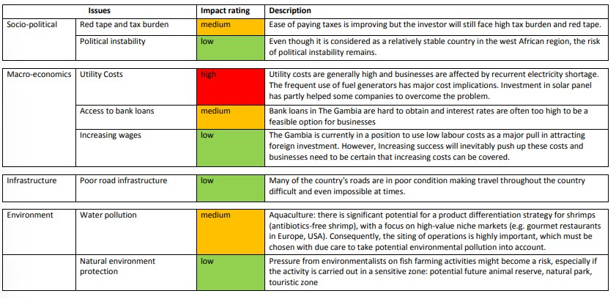

27

A helping hand every step of the way
- The Gambia Investment and Export Promotion Agency (GIEPA) is the Government Agency mandated to support companies with their investment, business and export development as well as support to MSMEs.
- From the initial provision of information right through to supporting the establishment, growth and development of an investment project, GIEPA is your supporting partner for doing business in The Gambia – every step of the way.
- Here are just a few of the ways in which GIEPA can support your business.
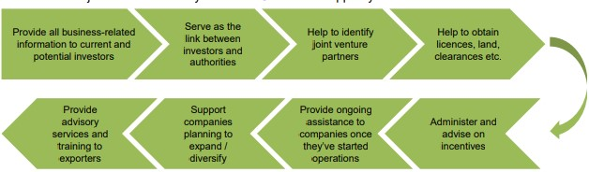
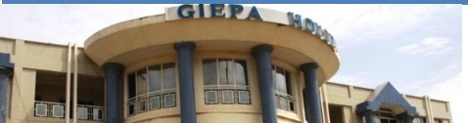

28

Reference
- World Economic Forum- Global Competitiveness ranking.
- UNCTAD. The fisheries sector in the Gambia: trade, value addition and social inclusiveness, with a focus on women
- Gambia Bureau of Statistics (GBOS) 10 World Economic Forum Global Competitiveness Report
- interviews of private investors in fish processing
- Gambia Bureau of Statistics.
- FAO , Food balance sheet statistics
- Gambia Ports Authority.
- GIEPA Regulations 2012.
- Ministry of Trade, Industry, Regional Integration and Employment’
- Ministry of Fisheries and Water Resources
- Coastal Resources Center
- Footsteps eco-lodge 13. Access Gambia.

29
