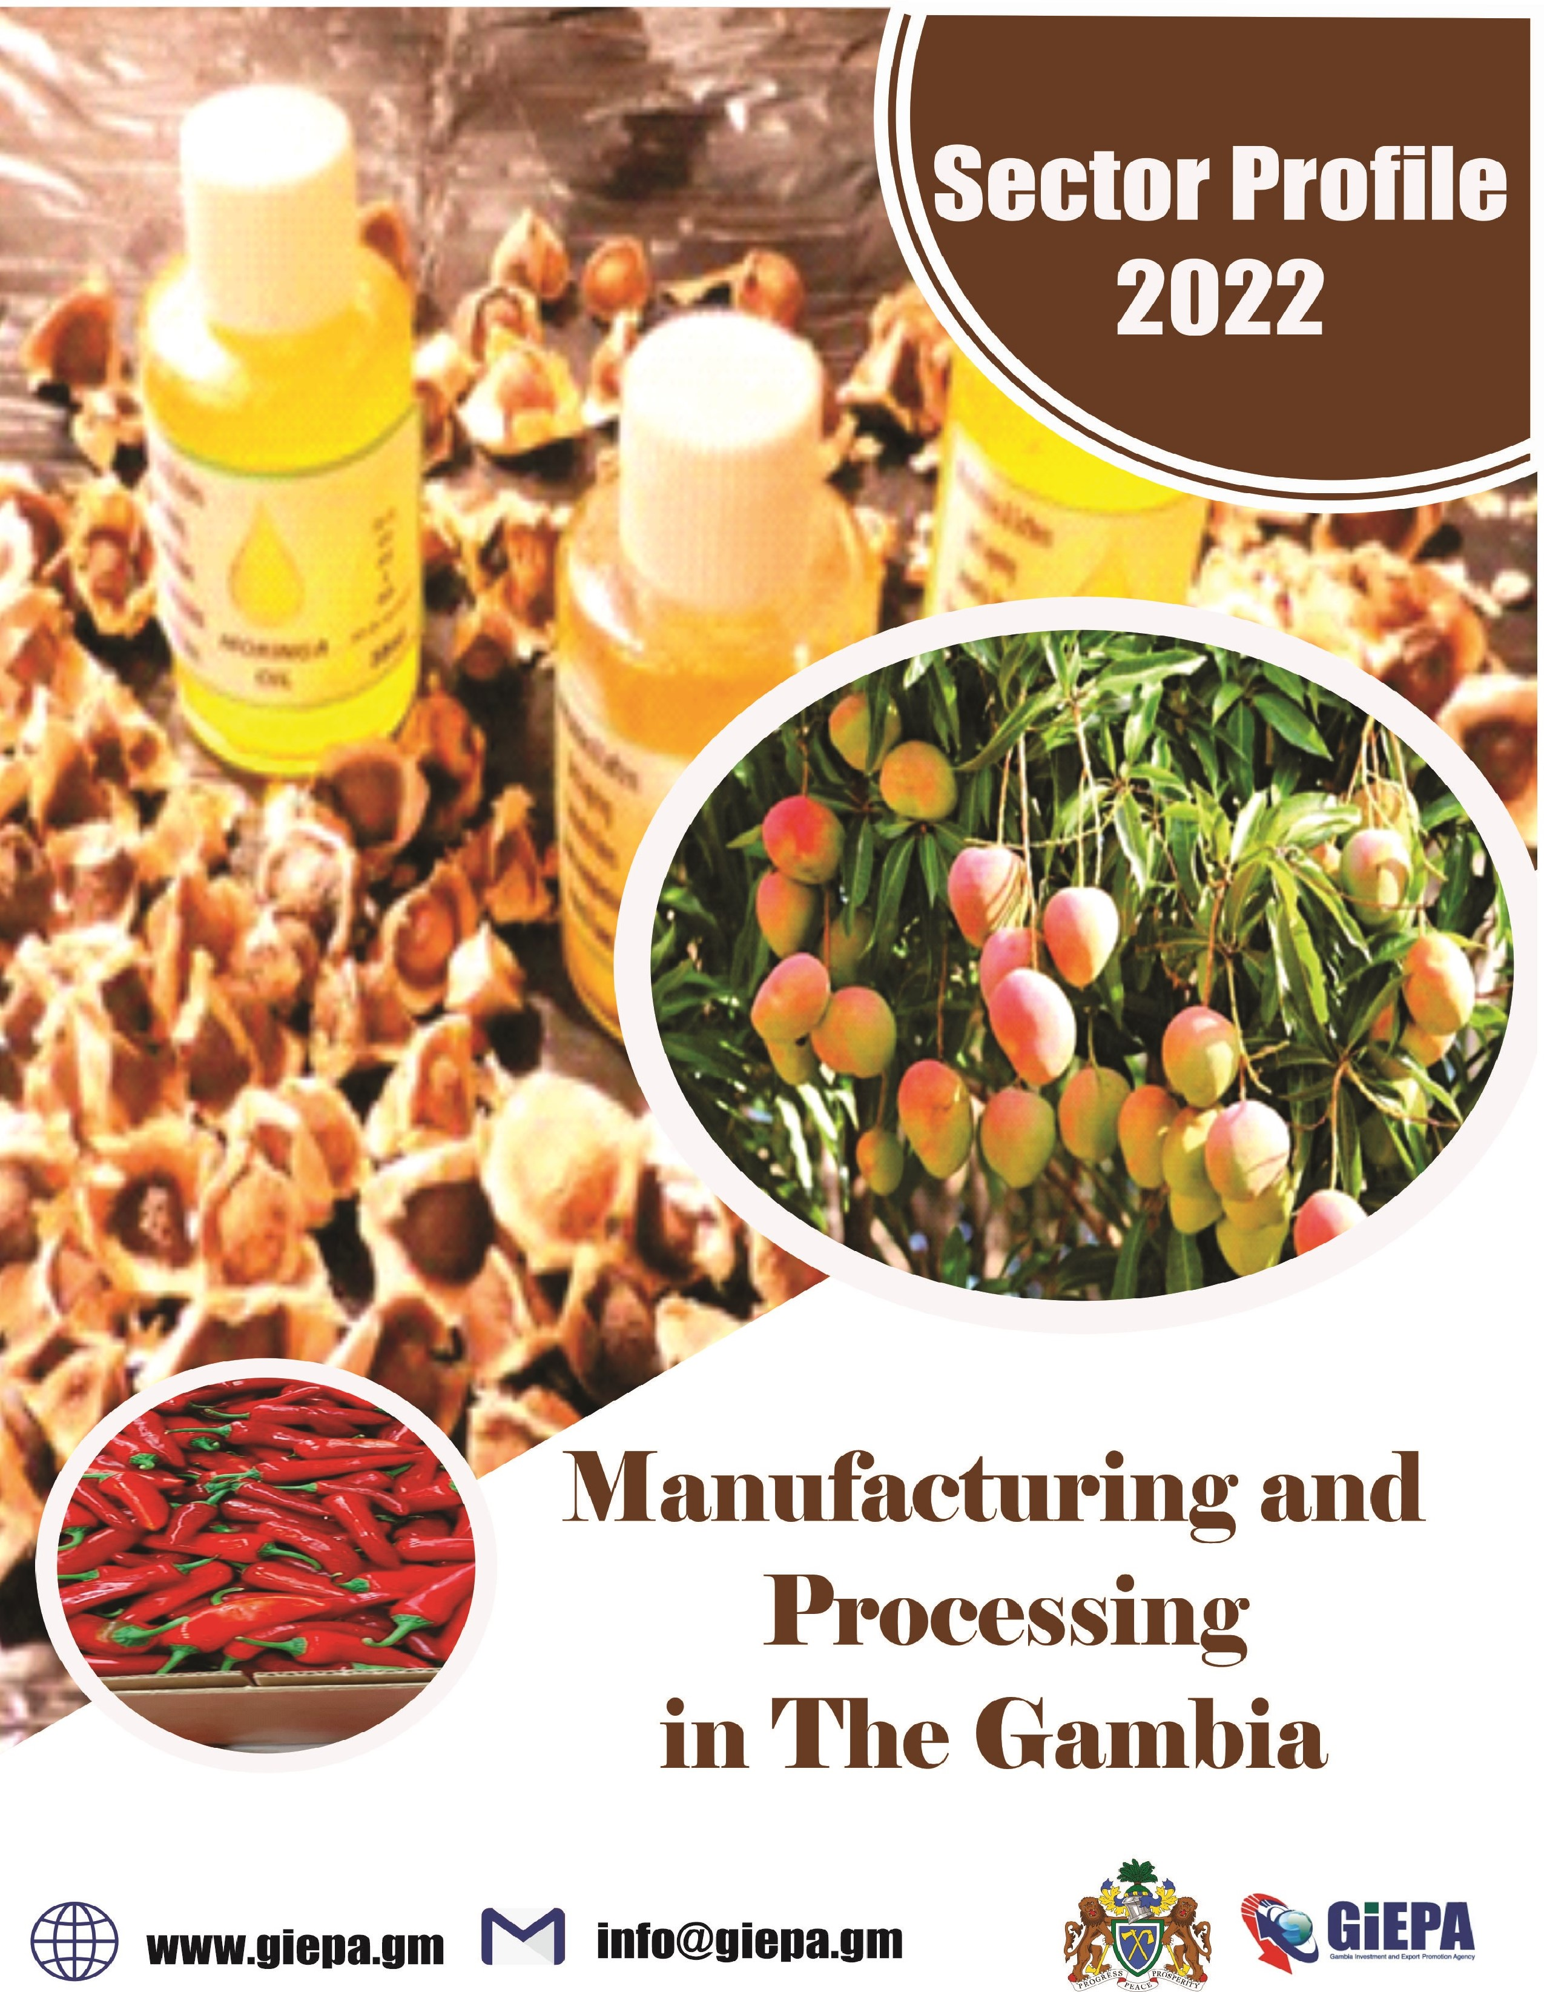

Table of contents
Manufacturing/Processing
Why The Gambia……………………………………………1 Economic indicators………………………………………...2
Infrastructure………………………………………………...3
Agri-Processing................................................................4
Biomass Processing........................................................7
Cashew Processing.........................................................8
Fruit and Horticulture......................................................10
Groundnut Processing...................................................12
Maize Processing...........................................................14
Packaging Operations....................................................15
Poultry Processing..........................................................18
Four good reasons to Choose the Gambia.....................19
Export Agreements..........................................................20
Availability of incentives..................................................21
Government Policy Position ..........................................22
A helping hand – every step of the way.........................23
Reference......................................................................24

Why The Gambia

Situated on the Atlantic coast and with a navigable river that flows more than 1,100km inland, The Gambia is the ideal entry and exit point for West Africa and the Economic Community Of West African States (ECOWAS).

This document outlines:
- The market opportunity for investment in groundnut production.
- The favourable conditions available to investors.
- The support investors can expect to receive.

One of the most competitive country in West Africa
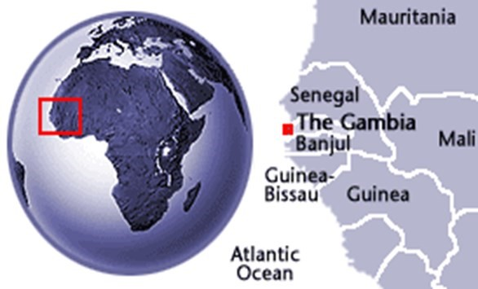
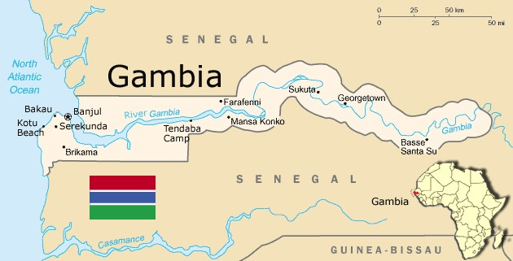
Home to the only West African river, easily accessible to ocean-going Average Crop Production one of the highest in West Africa
One of the best Agricultural Policy
Framework in West Africa

Economic Indicators

- GDP: US$2,036mm in 2021.
- GDP growth: 4.3% in 2021.
- Country risk: Lower risk level (yellow) than all neighboring countries
- CPI Inflation (2021): 7.607
- Exports / Imports value (2020) : - Exports: $28.7mm Import: $725.7mn.
- Labor force (2019) : 781,558
- FDI stock and inflows (2020): $519.217mm stock / $46mm inflows.
- Currency exchange rates (2021) – highs (H) and lows (L):
- GMD/USD: 52.61 (H)/51.07(L)
- GMD/GBP:71.1(H)/ 68.24(L).
- GMD/EUR: 61.87 (H)/60.57(L)
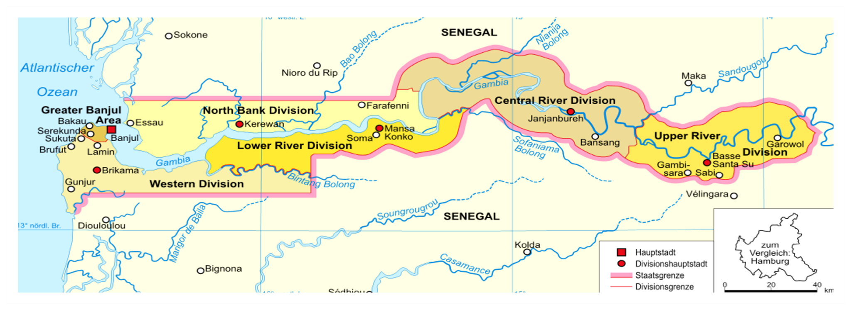
Infrastructure

- Banjul port has a handling capacity of:
⇒ 48 metric tonnes of bulk cargo per hour
⇒ 17 container moves (discharging and loading) per hour
⇒ The Trans-Gambia bridge
- Other new infrastructure / upgrades in development:
⇒ Improved cross-border trunk roads with Senegal
⇒ Ports Expansion Programme underway – Gambia Ports Authority planning to build a second port on the Atlantic coast
⇒ Ongoing infrastructure upgrades at Banjul International Airport
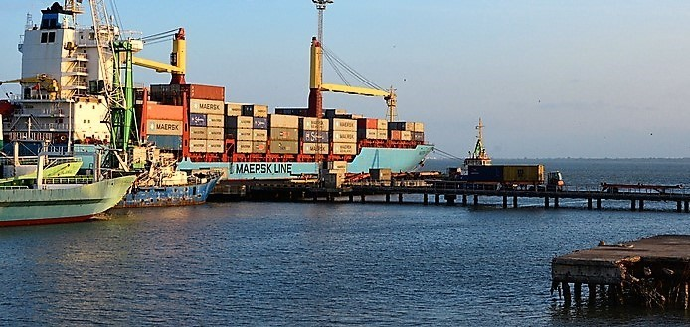
Agri
-
Processing

Agricultural Produce in The Gambia:
- The Gambia offers the ideal environment for a variety of processing facilities in terms of market demand, production levels and potential, know-how and supportive government policy.
- A wealth of agricultural products are grown and livestock reared in The Gambia, the country’s processing and export potential remains untapped.
- A lack of abattoirs, canning, chilling, freezing, juicing and other processing facilities mean that many products are either consumed locally during their short shelf life, exported raw, or even left to rot on the country’s streets.
- The expanding tourism sector is also a source of growing demand for processed locally-produced food and drink products.

Examples of Gambian Products
• The following provides a selection of Gambian products that offer investment opportunities for processing activities:
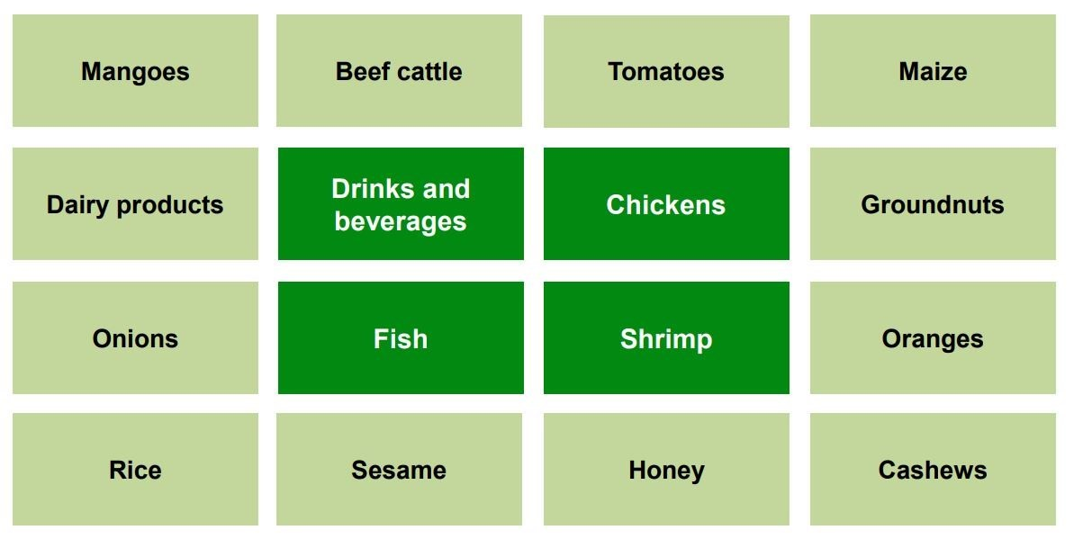
Products that offer untapped / largely untapped processing potential

Products already processed in The Gambia, although on a very low scale

:

Locations: The Gambia’s agricultural and agri-processing community
- The Gambia’s few agri-processing facilities are currently found in the Western-
: Region
- Other parts of The Gambia can also offer suitable processing locations, given agricultural production takes place throughout the country.
- The west coast offers easy access to Banjul’s port and international airport, while the north and south roads and navigable river ensure easy access from the rest of the country.
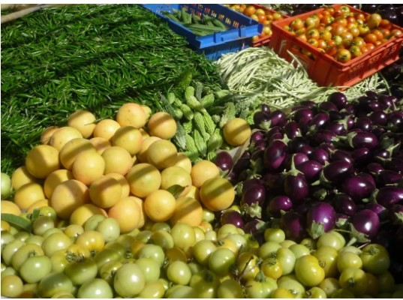

The Gambia’s agricultural and agri-processing community
- The Gambia is home to a community of relevant stakeholders for potential processing operations and a few examples of these organisations are displayed below. These groups include: − Producers that can provide inputs into processing operations − Businesses involved in (or planning) food and drink processing (highlighted in light green) − Supporting organisations (industry associations and representative groups)
- The presence of these groups demonstrate The Gambia’s attractiveness and potential as a prime location in West Africa for food and drink processing.
EXAMPLES OF ORGANISATIONS
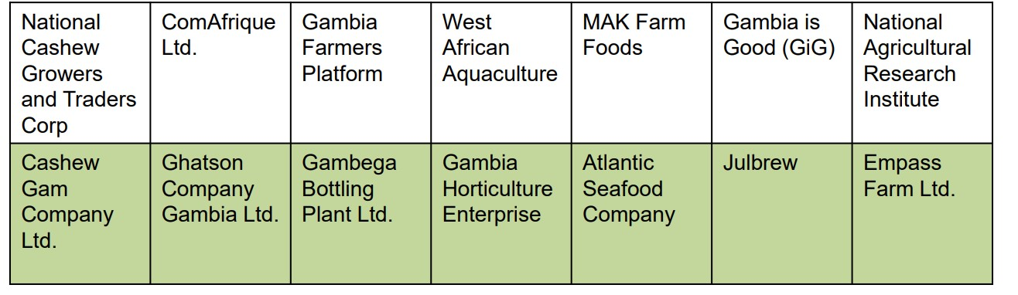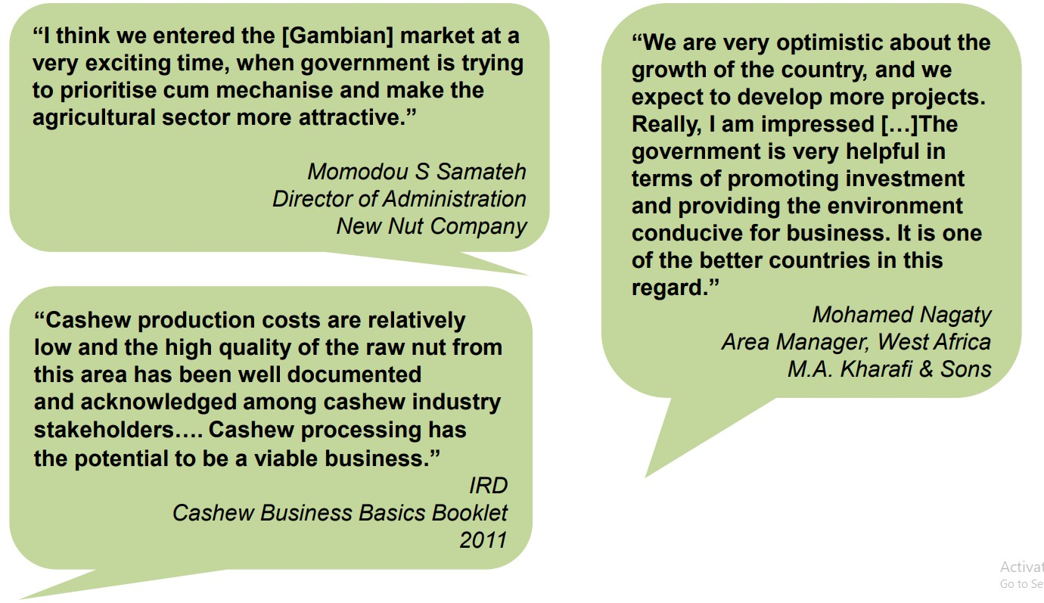
Biomass Processing

The Gambia’s Biomass Processing Potential:
- The Gambia’s population growth and expansions in infrastructure and business have triggered a rapid growth in electricity demand – significantly exceeding current capacity . The country’s agricultural, municipal, and industrial residues are unused and present an opportunity for biomass energy.
- At present, the groundnut processing facilities offer a centralized accumulation of groundnut shells.
- Recent feasibility assessment suggests that the use of groundnut shells in the Banjul-Kanifing area alone can produce an electricity supply of 600kW .
Locations

- Current biomass processing is concentrated the Western Region, although operations are feasible in several locations throughout The Gambia.
- The west coast offers easy access to Banjul’s port and international airport, while the north and south roads and navigable river ensure easy access from the rest of the country.

The Gambia’s biomass and energy community
- The Gambia is already home to a developed community of stakeholders either involved in or able to support biomass processing. The community consists of businesses, industry associations and representative groups. A few examples of these organisations are displayed below.
- The presence of these groups demonstrates The Gambia’s attractiveness and potential as a prime location in West Africa for biomass processing.
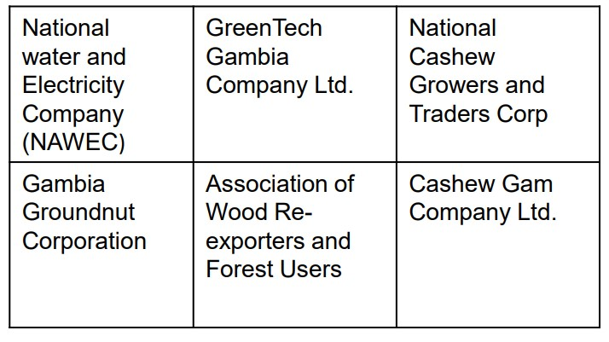
EXAMPLES OF ORGANISATIONS: 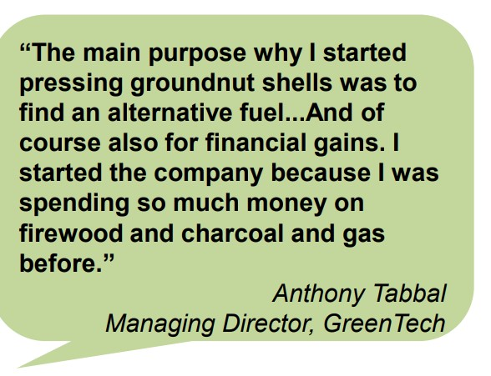
Cashew Processing
The Gambia’s Cashew Industry
- The Gambia offers the ideal environment for cashew processing in terms of production levels, know-how and available skills.
- Cashew plantations in The Gambia are relatively young with production potential expected to rise significantly within the next decade.
- The average Gambian cashew is larger in size than in competing countries (as measured by the lower average nut count per kg) .
- The market value of processed nuts nearly three times greater than raw nuts.
By-products and processing potential
- Cashews are the base of a very extensive and diverse set of products (listed below).
- The Gambia therefore offers important investment opportunities in processing activities that would enable value-added products to be developed and sold at a premium.
- Very little cashew processing is currently done in The Gambia. Existing investors such as Cashew Gam Company are considering future investment in cashew juice processing. Organisations like International Relief & Development (IRD) are supporting the development of cashew processing capabilities - this indicates an untapped area for potential investment EXAMPLES OF PRODUCTS:
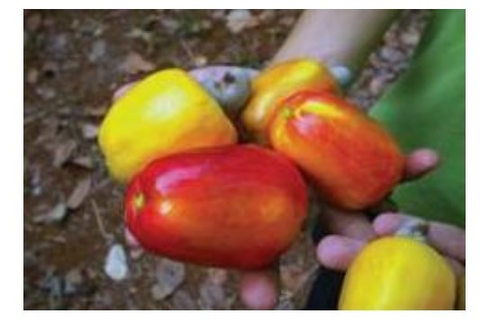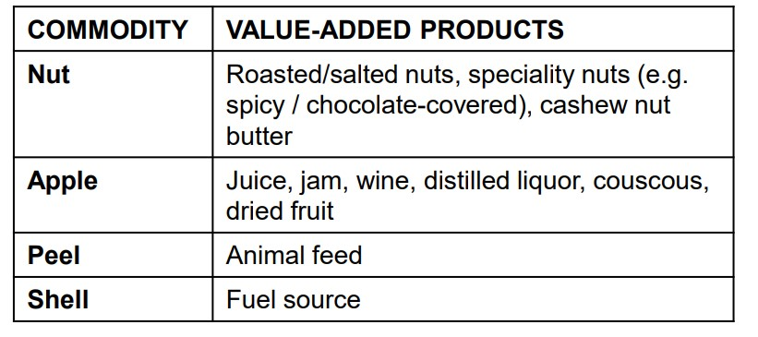
Location:Cashew Processing
- The current production of cashews is concentrated along the north bank and west coast areas, although they can be grown in almost all parts of The Gambia.
- The west coast offers easy access to Banjul’s port and international airport, while the north and south roads and navigable river ensure easy access from the rest of the country.
The Gambia’s cashew community
- The Gambia is already home to a developed community of stakeholders in the cashew industry (including businesses, industry associations and representative groups). A few examples of these organisations are displayed below
- The presence of these groups demonstrates The Gambia’s attractiveness and potential as a prime location in West Africa for the processing and export of cashew-related products.
EXAMPLES OF ORGANISATIONS:
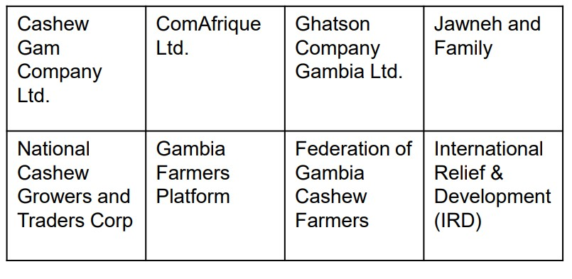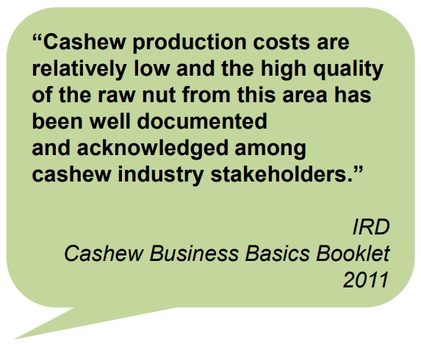
Fruit and Horticulture In the Gambia

- The Gambia offers the ideal environment for a variety of processing facilities in terms of market demand, production levels and potential, know-how and supportive government policy.

- A wealth of fruit and other horticultural products are grown in The Gambia, yet the country’s processing and export potential remains untapped.

- A lack of juicing, canning, chilling, freezing, and other processing facilities mean that many products are either consumed locally during their short shelf life, exported raw, or even left to rot on the country’s streets .

- The expanding tourism sector is also a source of growing demand for processed locally-produced fruit and other horticultural products:
The following provides a selection of Gambian fruit and other horticultural products that offer investment opportunities for processing activities:
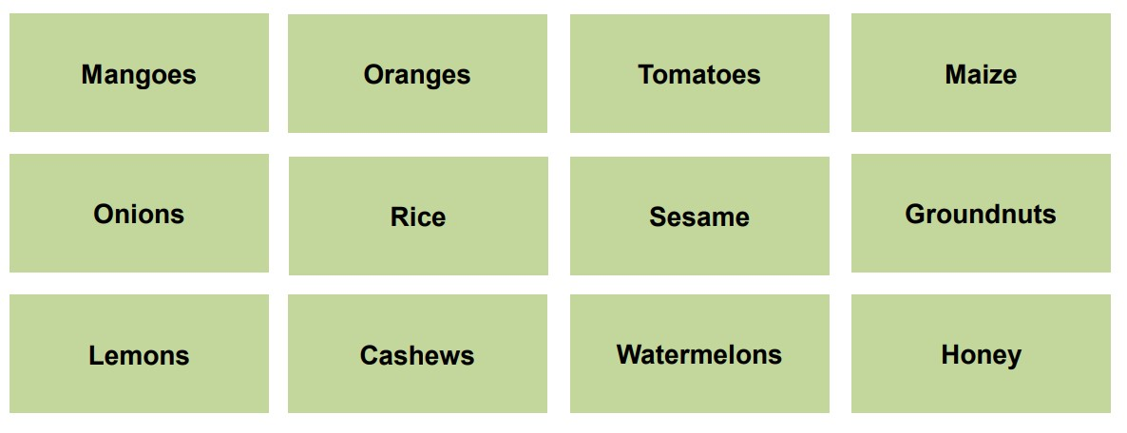
Location: The Gambia’s cashew community
The Gambia’s few agri-processing facilities are currently found in the Western Region. Other parts of The Gambia can also offer suitable processing locations, given agricultural production takes place throughout the country
The west coast offers easy access to Banjul’s port and international airport, while the north and south roads and navigable river ensure easy access from the rest of the country.

Fruit and Horticulture In the Gambia: The Gambia’s agricultural and agriprocessing community
⇒ The Gambia is home to a community of relevant stakeholders for potential processing operations and a few examples of these organisations are displayed below. These groups include: ◻ Producers that can provide inputs into processing operations.
- Businesses involved in (or planning) food and drink processing (highlighted in light green)
- Supporting organisations (industry associations and representative groups).

⇒ The presence of these groups demonstrate The Gambia’s attractiveness and potential as a prime location in West Africa for the processing of fruit and other horticultural products.
EXAMPLES OF ORGANISATIONS:
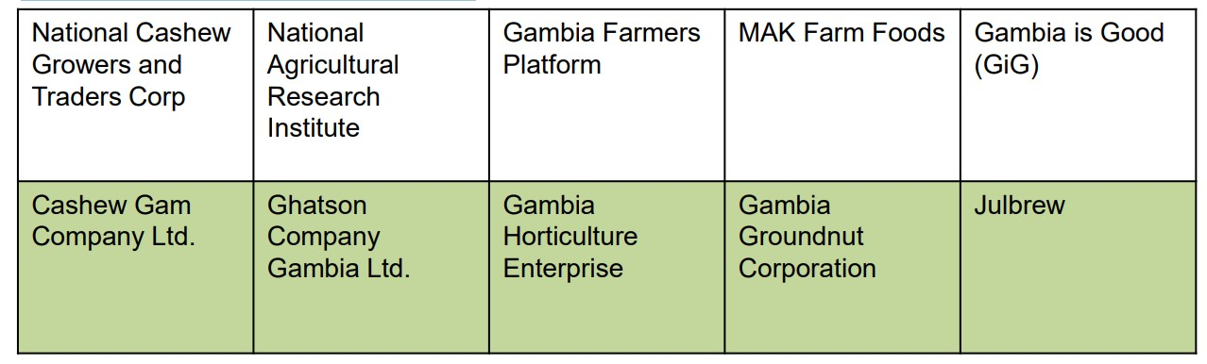
Investor testimonials
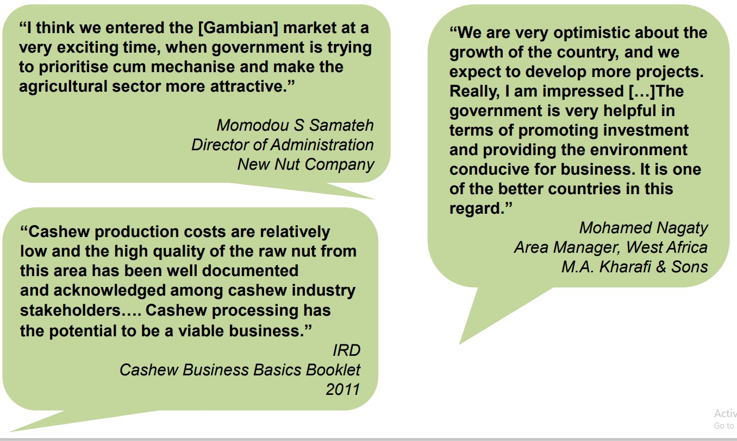

Groundnut Processing
The Gambia’s Groundnut Industry
- The Gambia offers the ideal environment for groundnut processing in terms of production levels, know-how and available skills .
- Groundnuts are grown throughout The Gambia and constitute one of the country’s principal exports .
Current groundnut shelling capabilities
- The Gambia’s groundnut shelling operations are concentrated in two key locations: − Denton Bridge (between Serrekunda and Banjul) − Kaur (western part of the North Bank)
- Capabilities at the two sites are as follows:
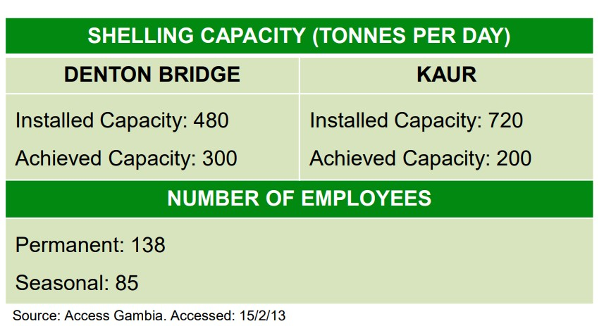

By-products and processing materials
- Groundnuts are the base of a diverse set of products – a recent report by the US Department of Agriculture’s Foreign Agricultural Service stated it is possible to derive 63 derivatives products from raw peanut – a small selection of these are presented here
- The Gambia therefore offers important investment opportunities in groundnut processing activities that would enable value added products to be developed and sold at a premium
- Very little groundnut processing is currently done in the Gambia, and many current exports are sold as low-value products (e.g. birdfeed) - this presents an untapped area of potential investment
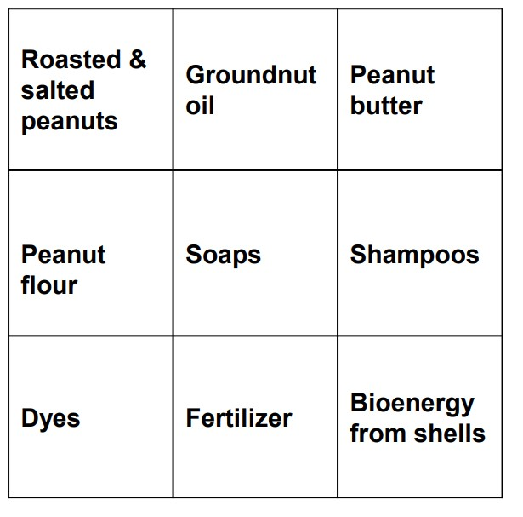

Location
- The current production of groundnuts concentrated along the north bank and south bank areas, although they can be grown in almost all parts of The Gambia.
- The west coast offers easy access to Banjul’s port and international airport, while the north and south roads and navigable river ensure easy access from the rest of the country.

Maize Processing for Poultry Feed in the Gambia
- With a government target to nearly double maize yield per hectare and a growing demand for poultry meat and eggs, The Gambia offers strong investment environment for the processing of maize.
- The Gambia currently only produces around 50% of its domestic cereals requirement and is heavily reliant on expensive imports.
- The Gambia has the potential to produce more maize – less than 60% of the country’s arable land resources is used.

Location
- Current production of maize is concentrated in the north bank region (Kerewan) although it can be grown in several locations throughout The Gambia.
- The west coast offers easy access to Banjul’s port and international airport, while the north and south roads and navigable river ensure easy access from the rest of the country.

The Gambia Cereal Community
- The Gambia is already home to a developed community of stakeholders in the cereals sector, including maize. The community consists of businesses, industry associations and representative groups. A few examples of these organisations are displayed below.
- The presence of these groups demonstrates The Gambia’s attractiveness and potential as a prime location in West Africa for the production and small-scale processing of maize for poultry feed.
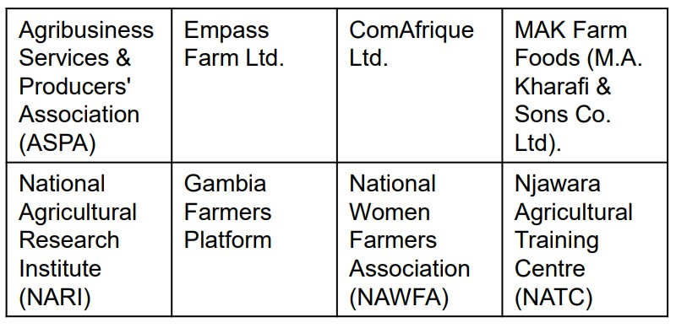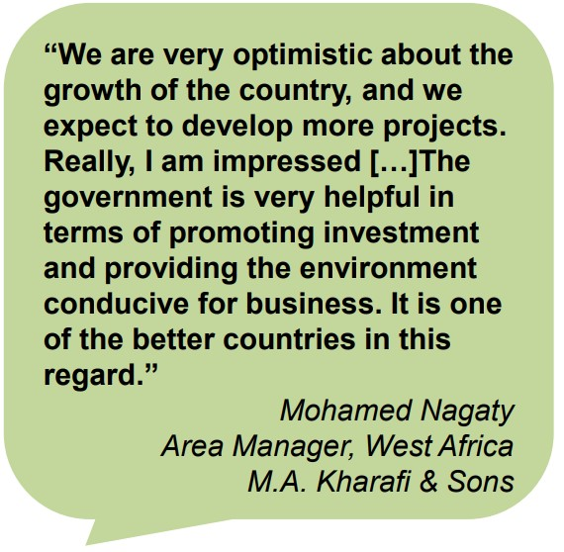

Packaging Operations in the Gambia
- The Gambia produces a significant and diverse set of agricultural and horticul tural products for domestic and international consumption, yet the country’s export potential is far from reached.
- A lack of packaging and labelling facilities is partly responsible for hindering this potential .
- The Gambia is also heavily reliant on imports of agricultural products. Here, there is a limited number of suppliers and facilities to repackage bulk imports and redistribute within The Gambia and wider ECOWAS markets
- Imported packaging can consequently represent 50% of the price of the end product for sale.
What can be packaged and labelled?
There is an unfulfilled need for a vast range of agri-processing products to be packaged and labelled in The Gambia – whether domestic products for local consumption and exports, or bulk imports for repackaging and selling in The Gambia and other ECOWAS markets. Here are just a few examples of products:
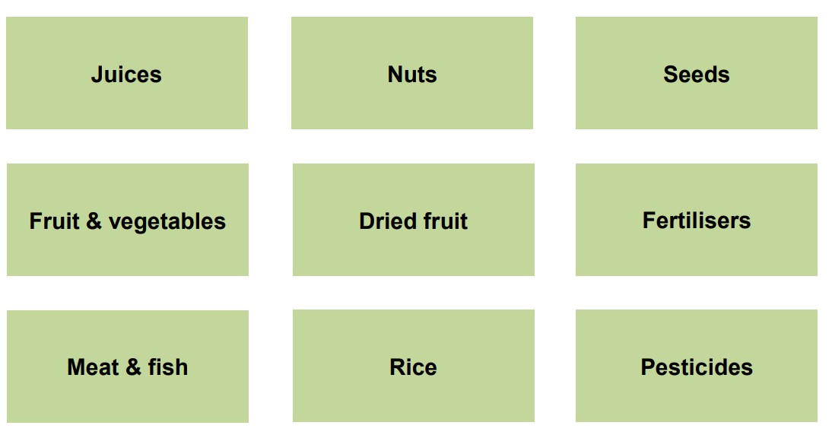
Location

- Boats with a draught of up to 6 metres can go as far as 300km up the River Gambia, while the north- and south-bank roads along the river ensure easy access throughout the country
- Goods can therefore easily be packaged, labelled and transported at various points throughout the country. Existing packaging operations are found in Serrekunda and the coastal region, although these are currently very limited.
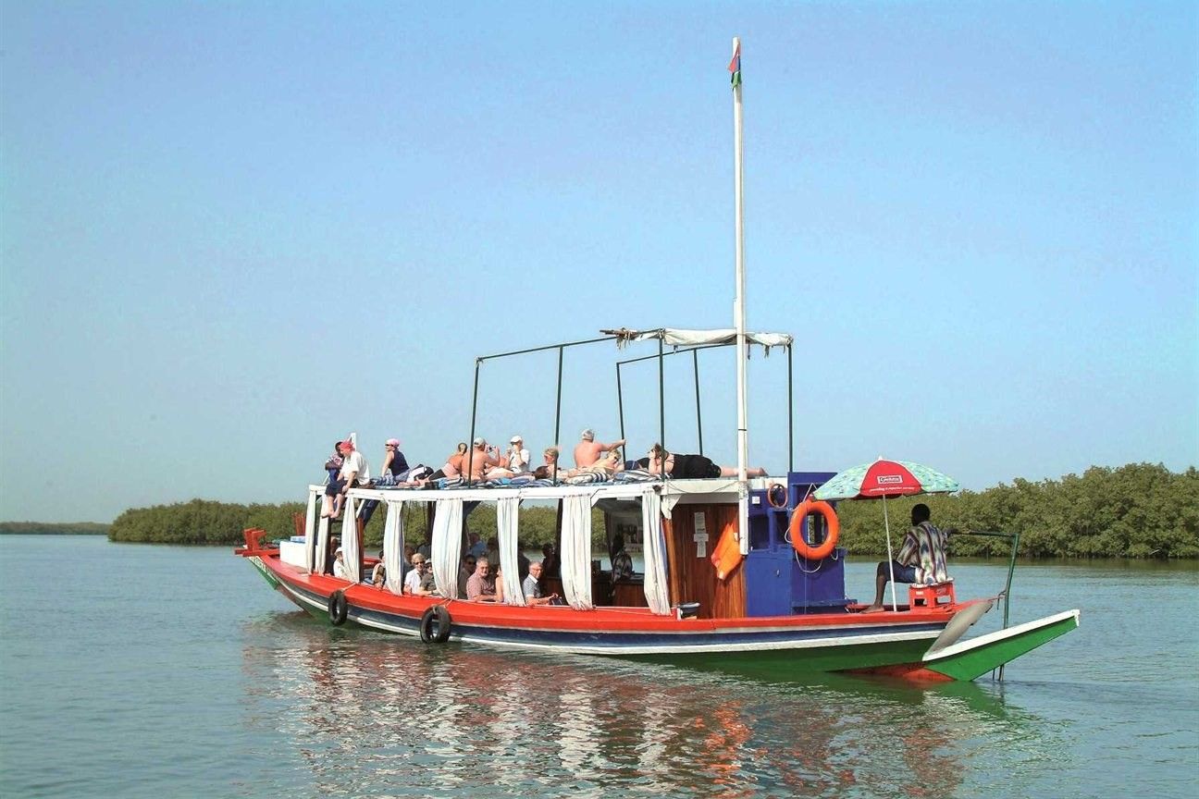
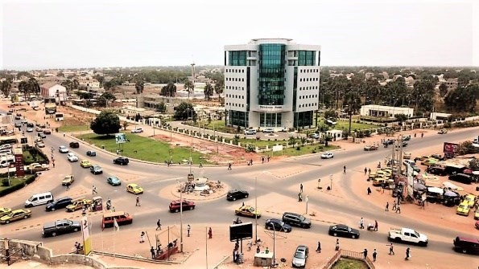

The Gambia’s agri-processing and packaging community
The Gambia is home to a developed community of agricultural, horticultural, fish and other FMCG businesses that require packaging and labelling supplies. There is currently a gap – and therefore potential market opportunity – in the supply of domestic packaging services, including cardboard, plastic and glass.
A few examples of organisations that require or could support domestic packaging operations are provided below.
The presence of organisations such as these demonstrates The Gambia’s attractiveness and potential for investment in the manufacture and supply of packaging and labelling.
EXAMPLES OF ORGANISATIONS:
Food Processors Association | MAK Farm Foods | Gambia Horticultural Enterprises Ltd (GHE)
National Cashew Growers and Traders Corp | Gambia Farmers  Flatform | Atlantic Seafood Company
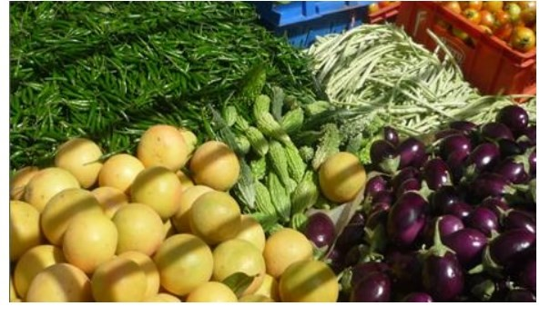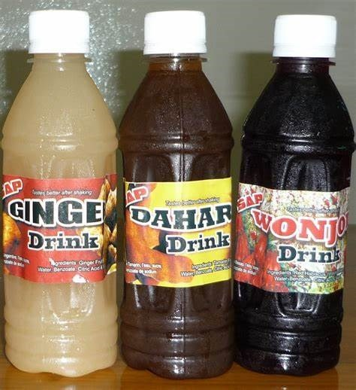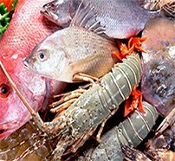
Poultry Processing in The Gambia

The Gambia’s Poultry Industry
- The Gambia offers the ideal environment for rearing and processing of poultry in terms of grazing land, climate, know-how and available skills. ◻ The Gambia is heavily reliant on poultry imports.
- There is strong demand for locally-processed chicken and other poultry products to supply the domestic and tourism market. This requires investment in abattoirs and cold storage facilities.
- This favourable investment environment is bolstered by political support – and an established target – to increase the supply of livestock products to the tourism sector.
Locations
- The Western Region has the highest concentration of commercial and backyard chickens, although poultry can be reared in many parts of The Gambia.
- The west coast offers easy access to Banjul’s port and international airport, while the north and south roads and navigable river ensure easy access from the rest of the country.
The Gambia’s poultry community
- The Gambia is already home to a developed community of stakeholders in the poultry industry (including businesses, industry associations and representative groups) – a few examples of these organisations are displayed below
- The presence of these groups demonstrates The Gambia’s attractiveness and potential as a prime location in West Africa for poultry processing. Examples of Organisations:
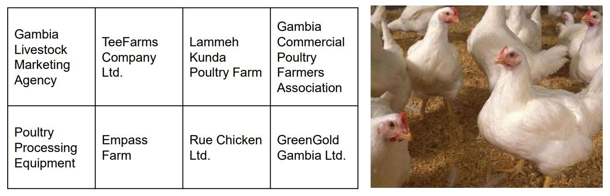
Four Good Reasons to Choose The Gambia
STRONG DEMAND, PRODUCTION LEVELS AND POTENTIAL:
- One of West Africa’s leaders in the Crop Production Index (World Bank)
- Increased production and exports of cashews and groundnuts
- Imported packaging up to 50% of the end product’s sale price

1
 |  | COMPETITIVE INVESTMENT ENVIRONMENT:
2 |  | - Best agricultural policy framework and the most competitive economy in West Africa (WEF 2012)  - West Africa’s most efficient labour market (WEF 2012)  - Lower political risk than neighbouring countries (Maplecroft)
STRONG AND IMPROVING INFRASTRUCTURE:
- River Gambia - easily accessible to ocean- going shipping
- Efficient port with competitive costs (fixed unit tariff system)
- New and upgrade projects underway, improving transport links with ECOWAS markets
3
ATTRACTIVE INCENTIVES, COMPETITIVE COSTS
- Generous incentives for packaging and labelling operations
- Competitive costs
- Strong political support for packaging and labelling
- Comprehensive guidance and support from GIEPA
4
Export Agreements

- Groundnuts and other Gambian agricultural products can be exported at preferential duty rates and quota free to:
  - ECOWAS markets under the ECOWAS Trade Liberalization
Scheme (ETLS)
  - EU market under the Everything But Arms (EBA) Initiative offered by the European Union
  - US market under the African Growth and Opportunity Act (AGOA)
  - India, Brazil and South Korea under preferential duty rates for prod ucts from Least-Developed Countries (LDCs)
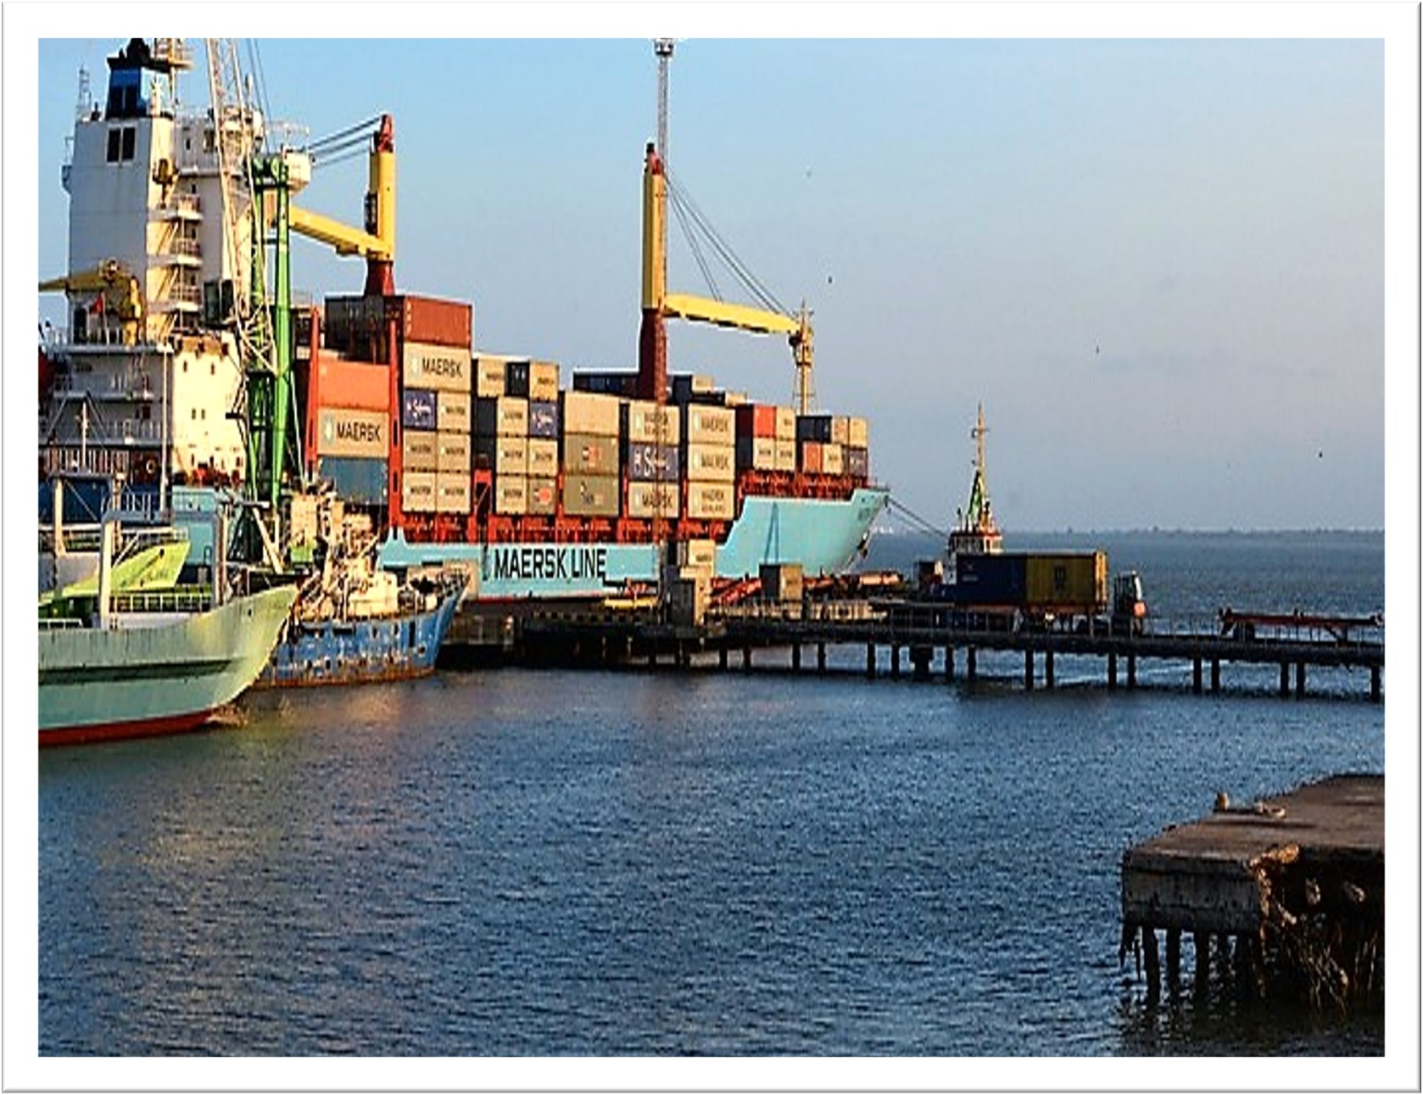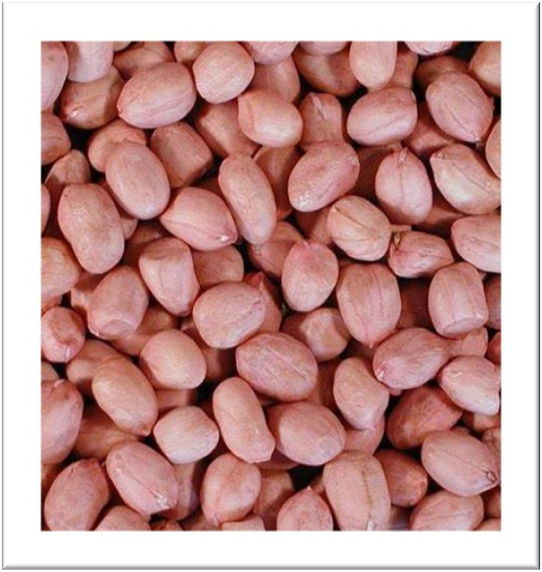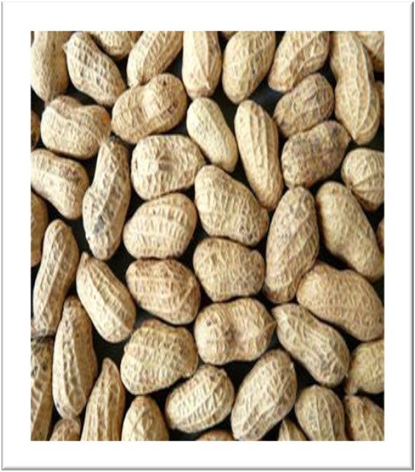
Availability of Incentives

- A host of incentives are available to investors in the groundnut production and processing sectors, provided certain criteria relating to investment value and job creation are met. These incentives include:
- Tax Holiday: tax breaks on corporate and turnover tax, withholding tax on dividends and for a period of 5-8 years, depending on the project’s location
- Import Tax Incentives: Exemption from payment of import tax on direct inputs for the project (e.g. agricultural machinery)
- Export Incentives: Exemptions / reductions on corporate and turnover tax, ex emption from Excise Duty and VAT on goods produced or imported within the Export Processing Zone (EPZ) for processing and export – depending on proportion of goods exported.
− No export tax on agricultural products

Operating Costs
- The Gambia has by far the most efficient labour market in West Africa and offers competitive costs in key areas such as agricultural labour.
- Preferential rates for key utilities such as energy and water are offered to operators in the agricultural sector.
- The cost of nut shipments from Banjul to key European ports are broadly in line with other ports in West Africa.

Government Policy Position
The Gambian Government recognizes the importance of private sector participation in the economy, both as an engine of growth and as a source of knowledge transfer. The Gambia National Agricultural Investment Programme (GNAIP) 2011-2015 is the national strategic framework for accelerated growth, poverty reduction as well as food, nutrition and income security

- As part of the Government’s efforts to promote industrial development, it is currently implementing a UNIDO Country Programme that includes a focus on the groundnut sector

- The Government also plans to:
  - Increase the number of accredited laboratories – supported by the EUfunded West African Quality Programme
  - Establish the Gambia Food Safety and Quality Agency (GFSQA), following the passing of the GFSQA Act in 2011

- The Ministry of Trade, Regional Integration and Employment (MOTIE) has recently finalized a Quality Assurance Framework for groundnuts

A Helping Hand—Every Step of The Way
- The Gambia Investment and Export Promotion Agency (GIEPA) is the Government Agency mandated to support companies with their investment, business and export development as well as support to MSMEs.

- From the initial provision of information right through to supporting the establishment, growth and development of an investment project, GIEPA is your supporting partner for doing business in The Gambia – every step of the way.

- Here are just a few of the ways in which GIEPA can support your business:

Provide all business
-
related information to
current and potential
investors

Serve as the link

between investors
and authorities

Help to identity
joint

venture partners

Help to identity
joint

venture partners

Provide advisory

services and
training to

exporters

Support

companies plan-
ning to expand/
diversify

Provide assis-
tance to compa-
nies once they
’
ve
started operations

Administrator and

advise

on incentives

Reference
- GIEPA Regulations.
- GNAIP Agriculture Investment Plan 2011-2015.
- World Economic Forum Global Competitiveness Report 2012-13.
3. Program for Accelerated Growth and Employment 2012– 15. 4. GIEPA Investment Guide 2012
- MF World Economic Outlook.
- Maplecroft Political Risk 2012.
- Ministry of Trade, Industry, Regional Integration and Employment.
- UN Commodity Trade Statistics Database.
- GIEPA Agriculture Investment Brochure 2012.
- Gambia Bureau of Statistics (GBOS) .
11.USDA Foreign Agricultural Service report: Revitalization of the Groundnut Sector in West Africa.
12.Gambia Ports Authority. Interviewed.
13.GIEPA Investment Guide.
14. The Gambia Trade Policy.
15.World Economic Forum Global Competitiveness.
16. Program for Accelerated Growth and Employment.
17.Ministry of Trade, Industry, Regional Integration and Employment: Summary of the Agriculture and Natural Resources Policy.
18. GNAIP Agriculture Investment Plan.

